Manager’s User Guide
PURE-XML

CHANGE
Version | Date | Sections changed | Description | Author(s)
1.0 | 08/01/2013 | All | Creation of document | IBO
1.1 | 08/05/2013 | All | Update of the document to address the new developments (Versioning) and the change to jQuery | CST
1.2 | 26/07/2013 | All | Update of the document to include the new functionality of Phase2/Iteration2. | CST
1.3 | 15/10/2013 | Sections related to Search and ACLs | Update of the document to include the changes in the search pages as well as the ACL functionalities | CST
1.4 | 10/12/2013 | Sections related to Search and Content Types | Update of the document to include the latest changes in the search pages | CST

Table of FIGURES

Figure 1: The main areas of the Repository Navigation page 12
Figure 2: Retrieve an object by providing the object URI 13
Figure 3: ‘Search’ button 13
Figure 4: “Simple Search” Screen 14
Figure 5: Search results of a Simple Search 14
Figure 6: Advanced Search by keyword 15
Figure 8: Advanced Search Process 16
Figure 9: ‘Order by’ feature 16
Figure 10: Add new logical unit from navigation panel 17
Figure 11: Add New Logical Unit window 17
Figure 12: Add new Folder button 18
Figure 13: Add New Folder window 18
Figure 14: Edit repository object from the action panel 18
Figure 15: Edit view of the repository object 19
Figure 16: ‘View all versions’ button in action panel 20
Figure 17: View all versions view 20
Figure 18: ‘View latest version’ button from action panel 20
Figure 19: Filter panel 20
Figure 20: Edit repository object from Contents view panel 21
Figure 21: Link a repository object to another from Contents view panel 21
Figure 22: Add Link repository object 21
Figure 23: Unlink repository object from Contents view panel 21
Figure 24: Move repository object from Contents view panel 22
Figure 25: Move repository object 22
Figure 26: Reorder repository object from Contents view panel 22
Figure 27: Re-order repository object 22
Figure 28: Delete repository object from Contents view panel 23
Figure 29: Lock repository object from Contents view panel 23
Figure 30: Lock repository object 23
Figure 31: Unlock repository object from Contents view panel 23
Figure 32: Unlock repository object 24
Figure 33: View versioning information of a repository object from Contents view panel 24
Figure 34: Versions tab of a repository object 24
Figure 35: Folder System Properties 26
Figure 36: Logical Unit System Properties 27
Figure 37: Content type properties 28
Figure 38: XML metadata properties 29
Figure 39: Content Types page 30
Figure 40: Add New Content Type 31
Figure 42: Upload XSL in content type 33
Figure 43: Upload CCS in content type 33
Figure 44: Edit tag 35
Figure 45: Access Control page 37
Figure 46: Add new user group 38
Figure 47: Filter by URI 39
Figure 48: Changelog table 39
Figure 49: Changelog table 40
Figure 50: Filter by date 40
Figure 51: Changelog table 41
Figure 52: Filter by UBI 41
Figure 53: Changelog table 41
Figure 54: Filter by ID 41
Figure 55: Changelog table 42
Figure 56: CSV Export 42
Figure 57: Delete changelog entries 42
Figure 58: Statistics page 43
Figure 59: Check out a folder 44
Figure 60: Check in 45
Figure 61: View relationships 46
Figure 62: Add new relationship to a folder 46
Figure 63: ACLs tab 47
Figure 64: “Update Access Control” window 47
Figure 65: Expand the “Update Access Control” window 48
Figure 66: Logical Composition table 49
Figure 67: Table of Languages 49
Figure 68: Add New Language 50
Figure 69: Versions tab for a logical unit 50
Figure 70: Versions sequence 51
Figure 71: Check out a logical unit 51
Figure 72: Add new relationship to a logical unit 52
Figure 73: ACLs tab 53
Figure 74: “Update Access Control” window 53
Figure 75: Expand the “Update Access Control” window 54
Figure 76: Add new Rendition 55
Figure 77: Check out a physical unit 56
Figure 78: Add new relationship to a physical unit 57
Figure 79: “Update Access Control” window 58
Figure 80: Expand the “Update Access Control” window 58
Figure 81: Add new relationship to an XML Rendition 60
Figure 82: “Update Access Control” window 61
Figure 83: Expand the “Update Access Control” window 62
Figure 84: Rendition content 63
Figure 85: Update Binary Renditions 63
Figure 86: Add new relationship to an XML Rendition 63
Figure 87: “Update Access Control” window 64
Figure 88: Expand the “Update Access Control” window 65
Figure 89: Update media 66
Figure 90: Add new relationship to an XML Rendition 66
Figure 91: “Update Access Control” window 67
Figure 92: Expand the “Update Access Control” window 67
Figure 93: Open the PWC area from the “Versions” tab 68
Figure 94: PWC area 69
Figure 95: The main areas of the Repository Navigation page 70
Figure 96: Retrieve an object by providing the object URI 71
Figure 97: ‘Search’ button 71
Figure 98: Filter panel 72
Figure 99: Folder System properties 73
Figure 100: Physical Composition table 75
Figure 101: Physical Unit Properties page 76
Figure 102: XML Rendition System properties page 78
Figure 103: Binary Rendition System Properties view 80
Figure 104: Rendition content 80
Figure 105: Media System Properties page 81

Table of Content
1. General Introduction 10
1.1. Purpose 10
1.2. Applicable and Reference Documents 10
1.2.1. Applicable Documents 10
1.2.2. Reference Documents 10
1.3. Glossary 10
2. General Description 11
2.1. General usage guidelines 11
2.1.1. Roles 11
3. Using the Management Console as an Administrator 12
3.1. Repository Navigation 12
3.1.1. Page Overview 12
3.1.2. Actions 12
3.2. Properties view 25
3.2.1. Page overview 25
3.2.2. Actions 29
3.3. Content Types 30
3.3.1. Page Overview 30
3.3.2. Actions 31
3.4. Tags 34
3.4.1. Page Overview 34
3.4.2. Actions 34
3.5. Relationships 35
3.5.1. Page Overview 35
3.5.2. Actions 36
3.6. Access Control 37
3.7. Changelog 38
3.7.1. Page Overview 38
3.7.2. Actions 39
3.8. Statistics 42
3.9. Folders 43
3.9.1. Page Overview 43
3.9.2. Actions 43
3.10. Logical Units 48
3.10.1. Page Overview 48
3.10.2. Actions 48
3.11. Physical Units 54
3.11.1. Page Overview 54
3.11.2. Actions 54
3.12. XML Renditions 59
3.12.1. Page Overview 59
3.12.2. Actions 59
3.13. Binary Renditions 62
3.13.1. Page Overview 62
3.13.2. Actions 62
3.14. Media 65
3.14.1. Page Overview 65
3.14.2. Actions 65
3.15. PWC area 68
3.15.1. Page overview 68
3.15.2. Actions 69
4. Using the Management Console as a User 70
4.1. Repository Navigation 70
4.1.1. Page Overview 70
4.1.2. Actions 71
4.2. Properties view 72
4.2.1. Page overview 72
4.2.2. Actions 73
4.3. Folders 74
4.3.1. Page Overview 74
4.3.2. Actions 74
4.4. Logical Units 74
4.4.1. Page Overview 74
4.4.2. Actions 75
4.5. Physical Units 75
4.5.1. Page Overview 75
4.5.2. Actions 76
4.6. XML Renditions 77
4.6.1. Page Overview 77
4.6.2. Actions 78
4.7. Binary Renditions 79
4.7.1. Page Overview 79
4.7.2. Actions 80
4.8. Media 81
4.8.1. Page Overview 81
4.8.2. Actions 81

General Introduction

Purpose
This document aims to present the necessary information for using the PURE-XML Management Console application.

Applicable and Reference Documents
This chapter sets out the reference documents on which this guide is based.

Applicable Documents
This section details the applicable documents used in drafting this document. The applicable documents are standards, specimen plans which need to be applied and whose application is verifiable.
N° | Title | Remarks
[1]
[2]
[3]

Reference Documents
This section details the reference documents used in drafting this document. Reference documents help in defining the project but are not directly applicable (e.g. software reference manuals, sample files from outside firms, meeting papers).
N° | Title | Remarks
[1]
[2]
[3]

Glossary
The glossary is available at ISMSnet : - Zone 'Vos indispensables'-Glossaire.
Abbreviation | Description
CSS | Cascading Style Sheets
CT | Content Type
HTML | HyperText Markup Language
MC | Management Console
PWC | Private Working Copy
URI | Uniform Resource Locator

General Description

General usage guidelines
The Management Console is compatible with the following browsers:
- Internet Explorer 8
- Firefox 3.6
If you are using Internet Explorer, please make sure that Google Frame is not installed.

Roles
The users of the PURE-XML MC application are classified in the roles listed below:
- Administrator: The administrator have access to all parts of the application, including:
  - update user-defined properties,
  - modify repository folders (add/delete/edit/move/link/lock),
  - modify the logical composition (add/delete/edit/move/link/lock logical items),
  - modify the physical layer of the unit (add/delete/edit/move/link/lock languages),
  - add/edit/link/move/delete/lock XML/Binary renditions,
  - add/edit/link/move/delete/lock media objects,
  - check out and view the versions history of the objects supporting versioning,
  - manage tags/relationships/ACLs of the objects supporting these functionalities,
  - add/modify/delete content types,
  - add/modify/delete relationships and
  - add/modify/delete tags
- User: Simple user has access to the browsing functions of the Repository navigation only. Simple user can also see properties and composition view of the selected repository object.

Using the Management Console as an Administrator

Repository Navigation

Page Overview
The “Repository Navigation” page is the PURE-XML MC application homepage. When the user logs into the system, the “Repository” tab is automatically selected.
The “Repository Navigation” page consists of three panels: action panel (red), navigation panel (yellow) and contents view panel (green).
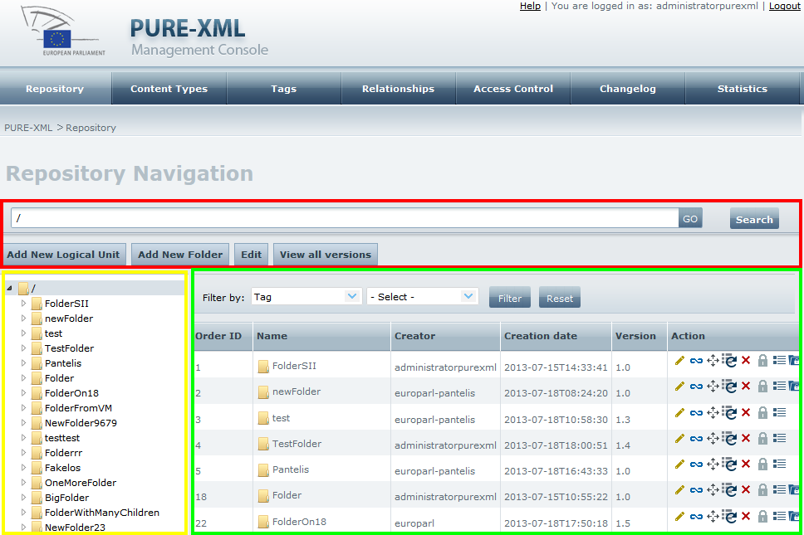
Figure 1: The main areas of the Repository Navigation page

Actions

Navigate through the repository objects
Click on a repository object in the navigation panel. If the selected object is not empty, its children (one level down) will be displayed in the contents view panel.
Click on the arrow in the left side of a repository object in the navigation panel to expand it in the navigation panel.

View the contents of a repository object from the contents view panel
Double-click on a repository object in the contents view panel to view its children objects (if any).

Go to object using object URI
To navigate to a specific location, fill in the URI of a repository object in the text box in the action panel and click on the “GO” button. The URI should include version numbers only for nodes in the path that are not the latest versions. For example, to retrieve the node /FOlDER:1.0/LogdoC:2.0/CE:1.0:
- Type /FOlDER/LogdoC/CE in case the version numbers of all nodes in the above path are in their latest version
- Type /FOlDER/LogdoC:2.0/CE in case the version numbers of all nodes in the above path are in their latest version, apart from LogdoC, which has a later version than version 2.0
If no version identifier is provided, the System will find the latest version of the object represented by the URI.
Figure 2: Retrieve an object by providing the object URI
The system will select the object with the URI provided (if such object exists) in the navigation panel and display the selected object’s contents in the contents view panel.
In case user fills in an invalid URI or a URI that no longer exists (e.g. due to the object having been moved, renamed or deleted in the meantime), the system will inform him/her with the corresponding error messages.
In addition, if a user provides a URI of a rendition or a media object in the text box, he/she will get an error message, as media and renditions are not depicted in the navigation panel.

Search
Click on the “Search” button, next to the “GO” button to open the Simple Search screen.
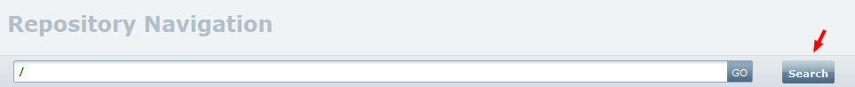
Figure 3: ‘Search’ button
The system opens the “Simple Search” screen where the “Search Root” field is already completed with the value that existed in the text field next to “GO” button, before the “Search” button was clicked.
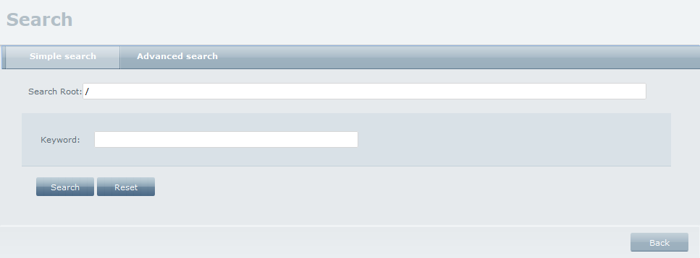
Figure 4: “Simple Search” Screen
You can edit the “Search Root” field and then fill in the “Keyword” field with the keyword you want to search inside the content of all the xml files under the “Search Root” (Search Root included) object. The “Search Root” may contain a full URI or alias. Note that version numbers should only be included in the alias URL to define node versions other than the latest version. Click on the “Search” button to view the search results.
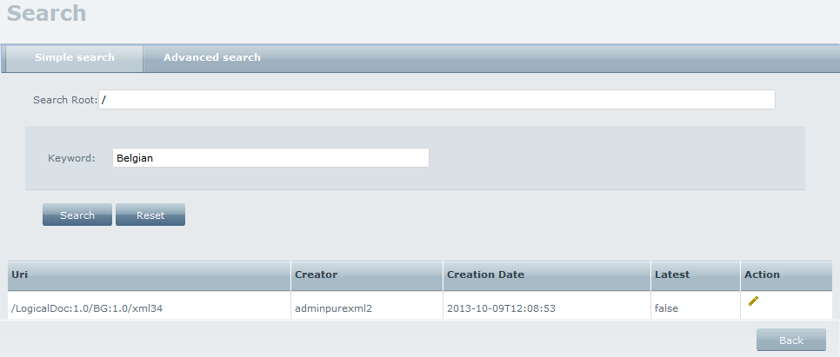
Figure 5: Search results of a Simple Search
Click on the “Reset” button in order to clear the search form from any used criteria and be able to perform a new search process.
Click on the button from the Search results table to view the System Properties screen of the corresponding object.
Click on the “Back” button to return in the Repository screen view.
Click on the “Advanced Search” tab to open the “Advanced Search” form.
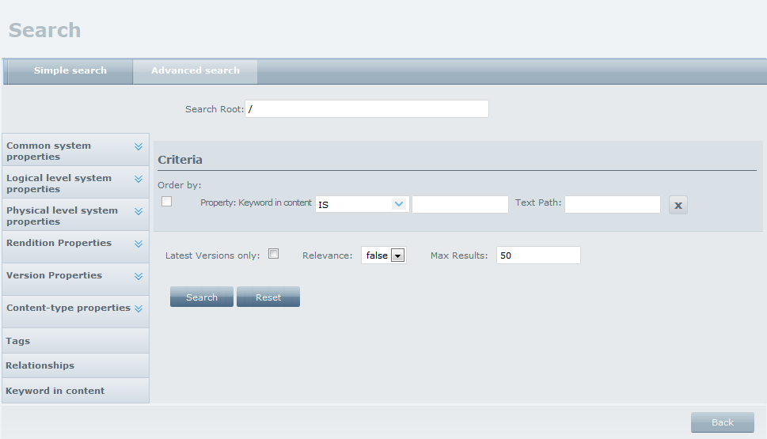
Figure 6: Advanced Search by keyword
By default, keyword search is loaded. Insert a keyword and valid Text Path expression to make the search inside the xml file more specific. On the left side of the Advanced Search screen, search criteria are grouped into the following categories:
‘Common System Properties’: Object_ID, Object_Type, Name, Locked, Lock_Owner, Creator, Creation_Date, State, URI.
‘Logical Level System Properties’: UBI, Unit_type, Content_type, Subject, Security_Code.
‘Physical Level System Properties’: UBI, Language, Original_language, Content_type
‘Rendition properties’: UBI, Language, Content_type, Size, Media_type
‘Version properties’: Version_id, Checkout, Version_label
‘Content type properties’: Choose among the properties of a content type and fill in the corresponding value.
‘Tags’: You can search among the existing tags.
‘Relationships’: You can search among the existing relationships.
The normal flow of the advanced search process is the following:
- Define the Search Root under which the search will be performed.
- Select any of the available search criteria from the left panel.
- ‘Build’ the search query using all the available operators (description follows) and filling in the values you are searching for.
- Perform search and view the search results in the same screen.
Click on the button to remove a search line from the query.
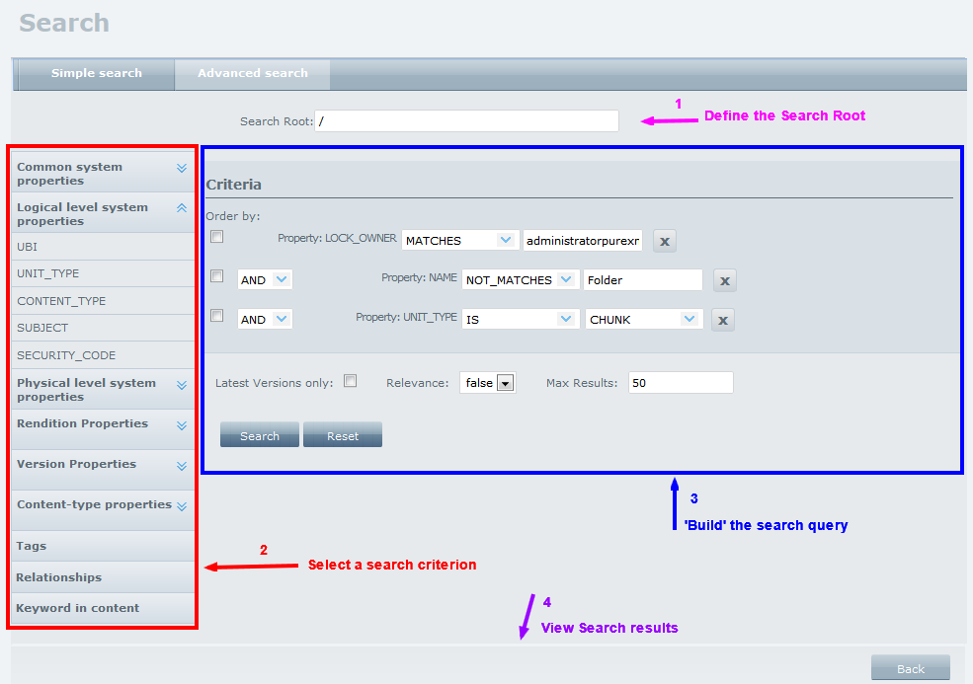
Figure 7: Advanced Search Process
Order by: Check the ‘Order by’ checkbox next to every search criteria you want the ordering to be applied.
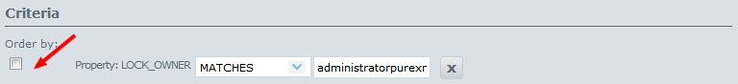
Figure 8: ‘Order by’ feature
Order by will perform Ascending ordering by default. Further reordering of the fetched results can be also performed from the re-ordering of the columns of the search results table.
Note: Using the ‘Order by’ property for creation date will only sort the results based on the creation day (without taking into account the creation time).
Operators for more than one criterion: When searching with more than one search criterion, the use of AND or OR operators is possible.
Operators related to the search criteria: The operators that can be used to specify the value of a search criterion are the following: is, is_not, contains, not_contains, equal, not_equal, greater, not_greater, less, not_less, matches, not_matches.
Click on the “Search” button to run the Search process.
Click on the button from the Search results table to view the System Properties screen of the corresponding object.
Click on the “Reset” button in order to clear the search form from any used criteria and be able to perform a new search process.
Click on the “Back” button to return in the Repository screen view.
General Note for Search: the search works on indexed objects only; the indexing runs in asynchronous mode (the indexing job is scheduled by the system administrator at fixed intervals), so newly created objects will not be retrieved at once through the search process.

Add New Logical Unit
Select a parent Folder or Logical Unit from the navigation panel and click on the “Add New Logical Unit” button from the action panel.
Figure 9: Add new logical unit from navigation panel
The system will open a popup for adding a new logical unit under the selected repository object.
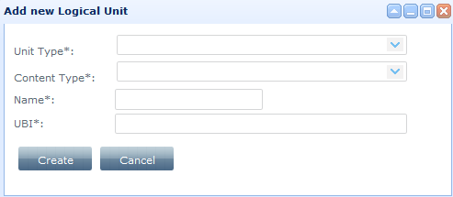
Figure 10: Add New Logical Unit window
Select the type of the logical unit (Logical Document, Information Block or Chunk), the content type, its name (only “~”, “-”, “_”, “.” special characters allowed in the name) as well as its UBI (all mandatory fields) and click on the “Create” button. A new logical unit will be created and the popup will be closed. To cancel the action of creating a new logical unit click on the “Cancel” button.

Add New Folder
Select a parent Folder from the navigation panel and click on the “Add New Folder” button from the action panel.
Figure 11: Add new Folder button
The system will open a popup for adding a new folder under the selected parent folder.
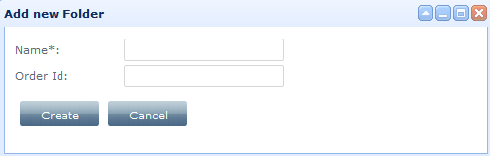
Figure 12: Add New Folder window
Fill in the name of the folder (mandatory, only “~”, “-”, “_”, “.” special characters allowed in the name) and the Order Id of the folder (optional) and click on the “Create” button. A new folder will be created. To cancel the action of creating a new folder, click on the “Cancel” button.

Edit repository object from the action panel
Select a repository object from the navigation panel and click on the “Edit” button from the action panel. The Edit view will be opened with tabs related to the selected object (Properties, Composition, Versions, Tags, Relationships and ACLs).
Figure 13: Edit repository object from the action panel
The properties tab is selected automatically. The administrator can navigate through the tabs, view all the properties of a selected repository object and perform various actions.
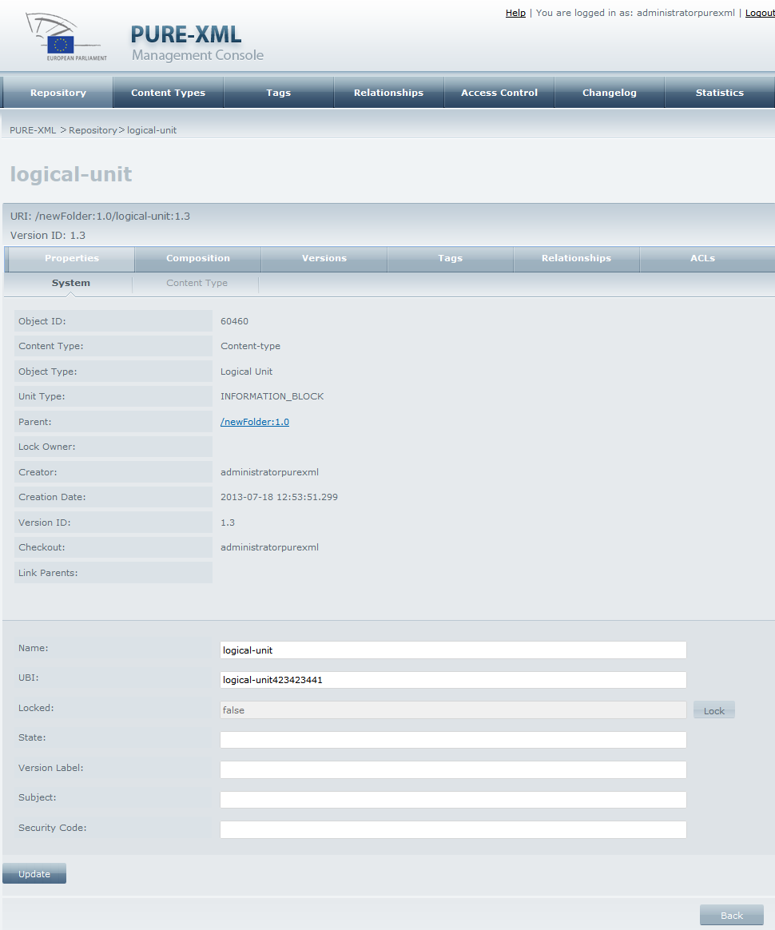
Figure 14: Edit view of the repository object
The Edit view page contains “Properties”, “Composition”, “Versions”, “Tags”, “Relationships” and “ACLs” tabs.
These tabs contain sub-tabs, which differ according to the repository object that is selected for edit.
All available actions for every type of repository object through the Edit mode are described in the sections corresponding to each repository object.

View all versions
Click on the ‘View all versions’ button from the action panel to see all the versions of all repository objects in both navigation and contents view panels.
Figure 15: ‘View all versions’ button in action panel

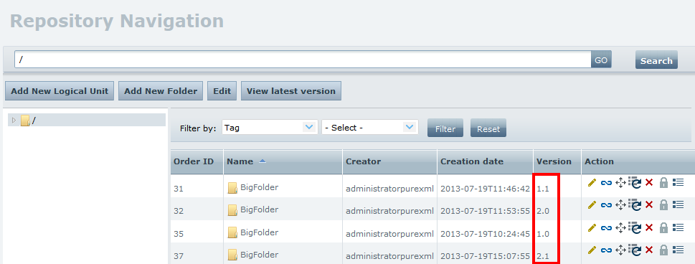
Figure 16: View all versions view

View latest version
Click on the ‘View latest version’ button from the action panel to restore the Repository view to show only the latest versions of the repository objects.
Figure 17: ‘View latest version’ button from action panel

Filter contents of folder and folder-derived objects
Click on a non-empty repository object from the navigation panel. From the action panel you can execute filtering by tag, content type property or system property.
Figure 18: Filter panel
Select filtering parameters choosing among Tag, System property or CT property and click on the “Filter” button. The system will execute filtering one level down form the selected object and refresh the content view pane, displaying only the items satisfying the selected filter.

Edit repository object
The edit action of a repository object can be also performed by clicking on the edit icon () next to the object you want to modify.
Figure 19: Edit repository object from Contents view panel
The properties tab is selected automatically. You can follow the exact same actions as they are described in 3.1.2.7 section.

Link repository object
To link a repository object to another one, click the link icon () next to the object you want to link, from the contents view panel.
Figure 20: Link a repository object to another from Contents view panel
The system will open a popup for linking the repository object.
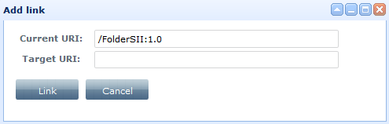
Figure 21: Add Link repository object
Fill in the URI of the target object you want to link to and press on the “Link” button. The system will link your object to the object having the URI you specified in the form. URI alias is supported here, so you can avoid entering version numbers in the URI for nodes that are in their latest version.

UnLink repository object
If you want to unlink an already linked repository object from the other object it is linked to, click on the unlink icon () from the contents view panel.
Figure 22: Unlink repository object from Contents view panel
The System will ask for your confirmation and will either unlink the object, either cancel the unlink procedure.
Please note that if it is for a linked object, the move, delete and lock actions are disabled.

Move repository object
Click on the move icon () next to the object you want to move, from the contents view panel.
Figure 23: Move repository object from Contents view panel
The system will open a popup for moving the selected repository object to another URI.
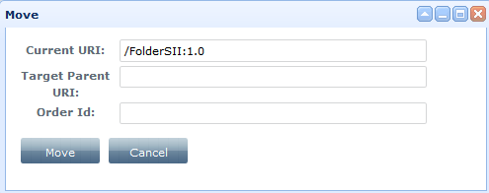
Figure 24: Move repository object
Fill in the target parent URI (mandatory) and the Order Id (optional) and press the “Move” button. URI alias is supported here, so you can avoid entering version numbers in the URI for nodes that are in their latest version. The system will move the selected repository object under the target parent URI.

Reorder repository object
Click on the reorder icon () next to the object you want to change the order from the contents view panel to change the order id of the repository object.
Figure 25: Reorder repository object from Contents view panel
The system will open a popup for setting the new order of the selected repository object.
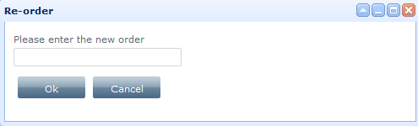
Figure 26: Re-order repository object
If you enter a value that is bigger than the existing maximum assigned order id, the system will set to the order id the next maximum value.

Delete repository object
Click on the delete icon () next to the object you want to delete from the contents view panel to delete a repository object.
Figure 27: Delete repository object from Contents view panel
The System will ask for your confirmation and will either delete the object (if the object is not empty), either cancel the delete procedure.

Lock repository object
Click the lock icon () from the contents view panel to lock a repository object.
Figure 28: Lock repository object from Contents view panel
The system will open a popup for locking the selected object.
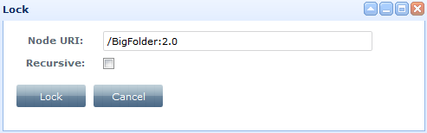
Figure 29: Lock repository object
To lock all underlying objects as well, click on the “Recursive” check box. To complete the action, click on the “Lock” button. The system will lock the selected object(s). Click on the “Cancel” button to cancel the lock procedure.

Unlock repository object
If the repository object is locked, click the unlock icon () from the contents view panel.
Figure 30: Unlock repository object from Contents view panel
The system will open a popup for unlocking selected object.
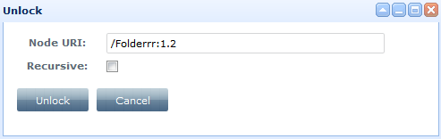
Figure 31: Unlock repository object
To unlock all underlying objects select the “Recursive” check box. To complete the action, click on the “Unlock” button. The system will unlock the selected object(s), if the user that unlocks this object is the lock owner. In the opposite case, the lock action cannot be completed.

Versioning information of the repository object
Click on the versions icon () from the contents view panel to open the “Versions” tab of the repository object.
Figure 32: View versioning information of a repository object from Contents view panel
The “Versions” table contain all the information regarding the versions of the specific object. The version id of a PWC object is formed as follows: (version_id_of_the_checked_out_object)?PWC. More details regarding the object versioning will be included in each separate ‘Actions’ section of every repository object.
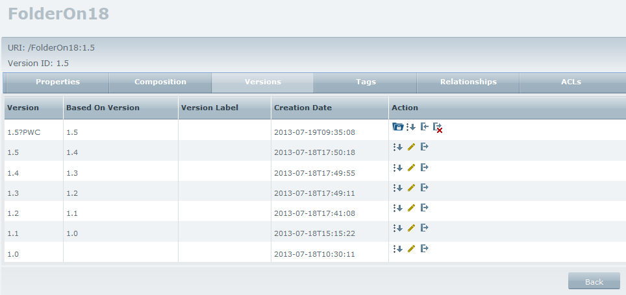
Figure 33: Versions tab of a repository object

View PWC area
Click on the pwc area icon () from the contents view panel to open the PWC area of a specific checked-out repository object. Only the user that has checked-out the object is able to navigate through its PWC area. Otherwise, an error message appears, informing the user that the object is checked out by another user.

Properties view

Page overview
The administrator may access Properties View page by clicking on the “Edit” button (for the object selected in the navigation panel) or the edit icon () from the Repository Navigation page (for the target object displayed in the contents view panel). The “Properties” tab will be selected automatically. The administrator can navigate through the tabs, view all the properties of a selected repository object and perform various actions.
The Properties view page can have one, two or three tabs: System (for system properties, applicable to all repository objects), Content Type (for content type properties, applicable to all repository objects except for Folders) and XML metadata properties (for XML metadata properties applicable for XML rendition objects only).

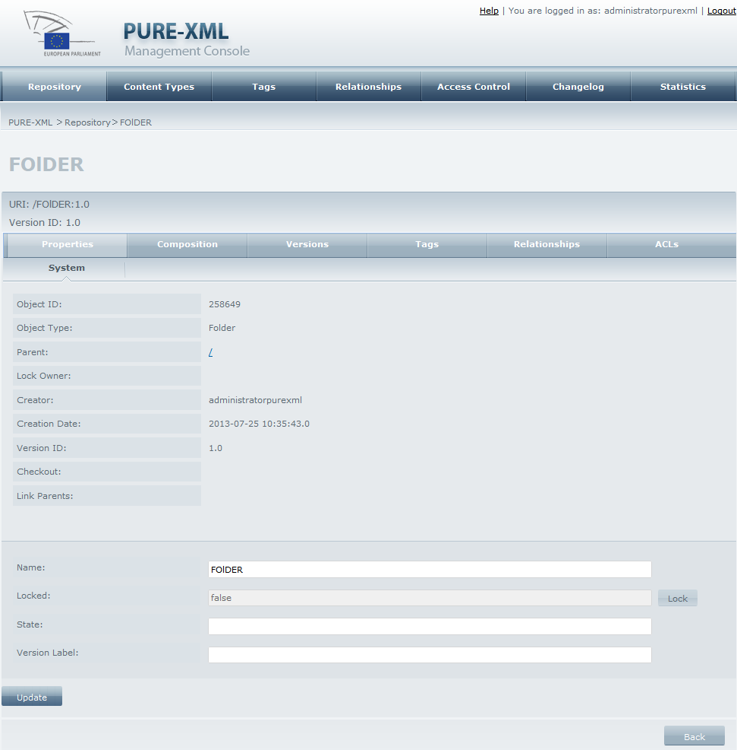
Figure 34: Folder System Properties

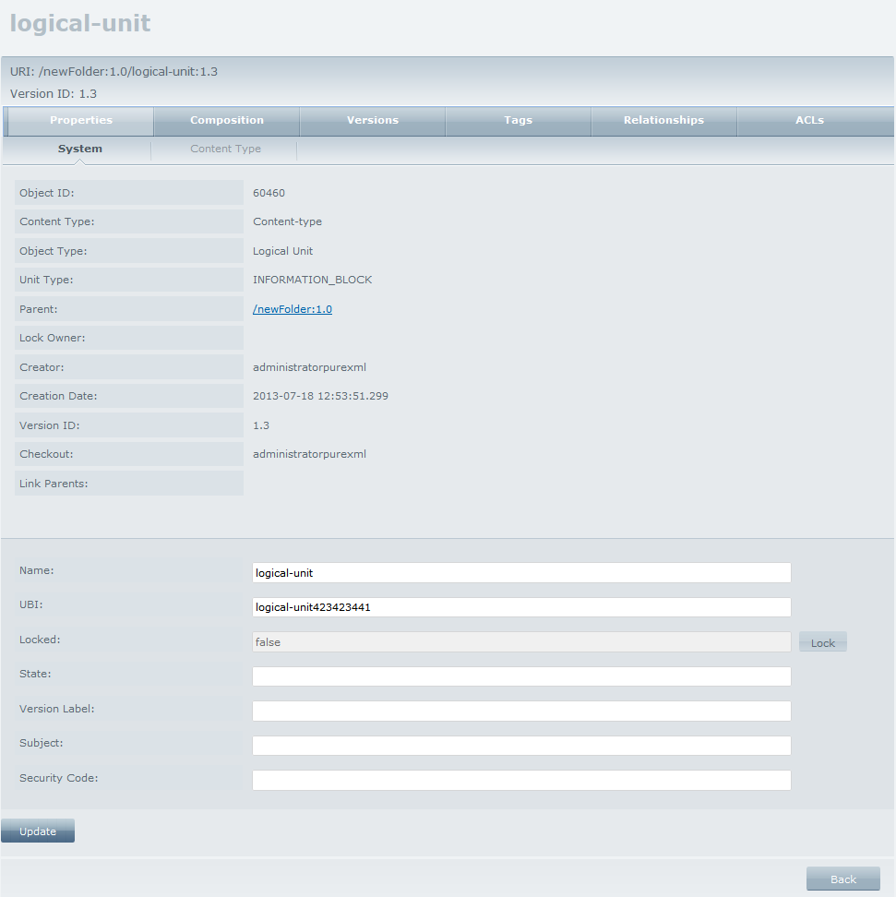
Figure 35: Logical Unit System Properties

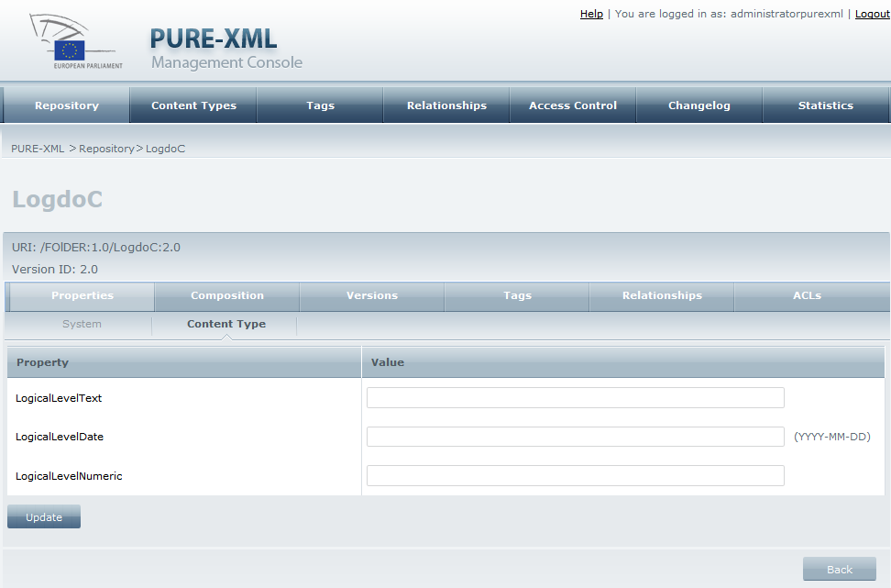
Figure 36: Content type properties

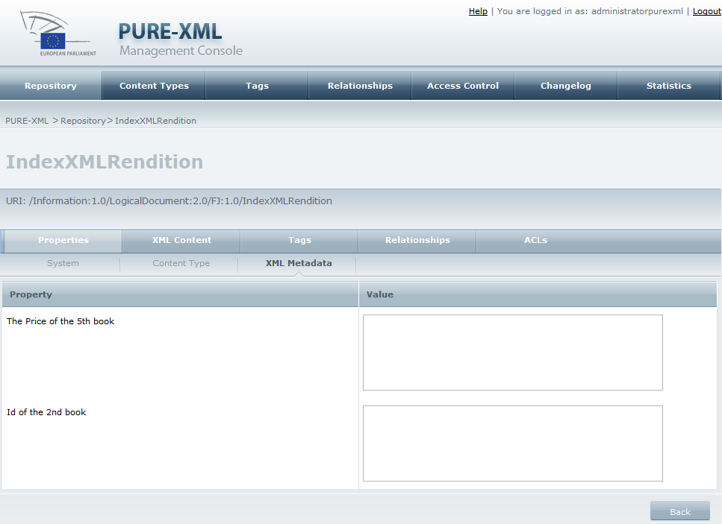
Figure 37: XML metadata properties

Actions

System Properties – View properties
Click on the “Properties” tab and on the “System” subtab to have a view of all repository object System properties.

System Properties- Go to parent object
Click on the “Parent” link from the system properties tab. The system will redirect you to the Repository Navigation page. The parent object will be selected. If parent has child objects, it will be expanded and its child objects will be displayed in the contents view panel.

System Properties – Go to link parent
Click on the “Link Parents” link from the system properties tab. The system will redirect you to the Repository Navigation page. The link parent object will be selected. If link parent has child objects, it will be expanded and its child objects will be displayed in the contents view panel.

System Properties- Lock/Unlock repository object
If the selected repository object is not locked, click on the “Lock” button to lock it (same lock action as from the Repository Navigation page). If selected object is locked, click on the “Unlock” button to unlock it (same unlock action as from the Repository Navigation page).

System Properties - Update system properties’ values
Change any System property values (i.e. Name, UBI (for all objects except for folders), State, Version label, Subject, Security Code, and others, depending on the object type) in the form and click on the “Update” button. The system will update the system properties for the selected object.

Content type properties - View Content type properties
Click on the “Properties” tab and on the “Content Type” subtab to have a view of all the object’s Content type properties, along with their values.

Content type properties - Update Content type properties’ values
Click on the “Properties” tab and on the “Content Type” subtab. Edit the value of the content type properties and click on the “Update” button to save the changes.

XML Metadata Properties - View XML Metadata Properties
Click on the “Properties” tab and then on the “XML Metadata” subtab to have a view of all the XMLs rendition Metadata Properties and their values.

Content Types

Page Overview
The administrator may access the Content Types page by clicking on “Content Types” tab from the main menu. The administrator can see the available content types and manage the content types of the system.
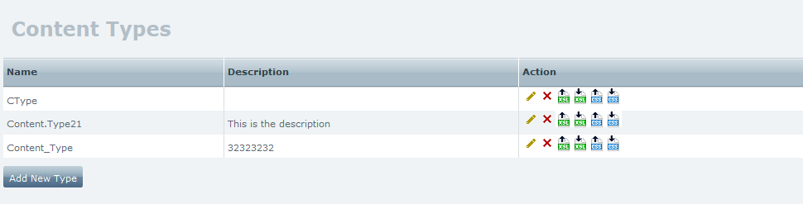
Figure 38: Content Types page

Actions

Add new content type
Click on the “Add New Type” button. The system will open a popup for adding a new content type.
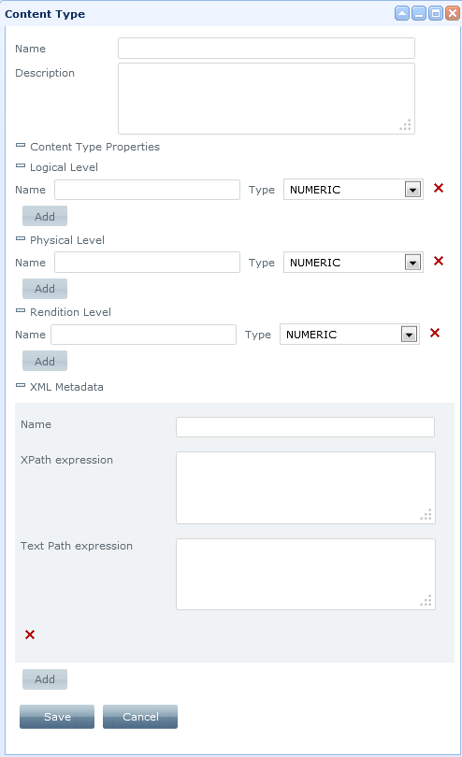
Figure 39: Add New Content Type
You can define the name (only “~”, “-”, “_”, “.” special characters allowed in the name), the description of the content type, as well as the name and the type of the logical level, the physical level and the rendition level properties and the name of any XML metadata property.
For every XML Metadata property you add, you can fill in an XPath expression, which will retrieve the corresponding value from the xml rendition; this value will be visible when user views the XML Metadata properties page (see Figure 37: XML metadata properties). In addition, you can fill in a Text Path Expression which will create a specific path that will be used in advanced search screen when you search with Content Type XML Metadata Properties values. If no Text Path is inserted in this field, search with Content Type XML Metadata Properties values will return no results.
Fill in the form, then click on the “Save” button. The new content type will be added and displayed in the table of content types. Click on the “Cancel” button to cancel the process.

Edit content type
Click on the edit icon () next to the content type you want to edit from the table of content types. The system will open a popup window for editing the selected content type.
You can edit the description of the content type, but not its name.
Click on the expand icon () to expand the Content Type Properties, Logical/Physical/Rendition Level properties or XML Metadata properties.
For Logical, Physical and Rendition level properties, you can add a new one by clicking on the “Add” button or remove an existing one by clicking on the delete () button.
For XML Metadata properties, you can add a new or delete an existing property. You can also edit the XPath and TextPath expressions but not the name of an existing XML Metadata Property.
Click on the “Save” button to save any changes, or the “Cancel” button to discard them.

Delete content type
Click on delete icon () next to the content type you want to delete from the table of content types. The selected content type will be deleted and removed from the table of content types only if it is not used by any repository object.

Upload XSL file
Click on the XSL upload icon () next to the content type you want to add the XSL file to, from the table of content types. A pop up window appears.
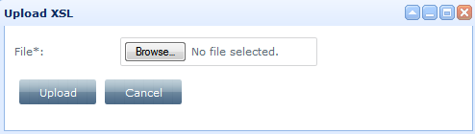
Figure 40: Upload XSL in content type
Select an XSL file to upload and click the “Upload” button. Click on the “Cancel” button to cancel the procedure.

Download XSL file
Click on the XSL download icon () to download the XSL uploaded for a specific content type. You can choose either to open or save the file. If no XSL has been uploaded, “File does not exist” error message appears.

Upload CSS file
Click on the CSS upload icon () next to the content type you want to add the CSS file to from the table of content types. A pop up window appears.
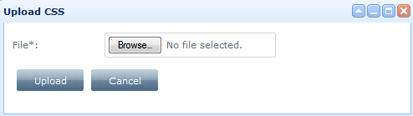
Figure 41: Upload CCS in content type
Select a CSS file to upload and click the “Upload” button. Click on the “Cancel” button to cancel the procedure.

Download CSS file
Click on the CSS download icon () to download the CSS uploaded for a specific content type. You can choose either to open or save the file. If no CSS has been uploaded, “File does not exist” error message appears.

Tags

Page Overview
The administrator may access the Tags page by clicking on the “Tags” tab from the main menu. The administrator can see all the available tags and create a new, edit or delete an existing tag.
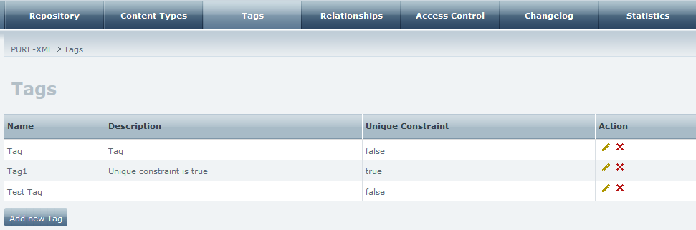
Figure 28: Tags page

Actions

Add new Tag
Click on the “Add new Tag” button. The system will open a popup window for adding a new tag.
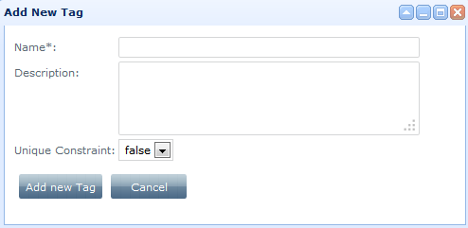
Figure 29: Add New Tag

Fill in the name of the tag (mandatory, only “~”, “-”, “_”, “.” special characters allowed in the name), a description for this tag (optional), set the value for the unique constraint variable (‘false’ by default) and click on the “Add new Tag” button. A new tag will be added and displayed in the table of tags. Click on the “Cancel” button to cancel the process. (A tag that has been created with the unique constraint enabled can appear only for one object of the version series, if the object is versionable.)

Edit Tag
Click on the edit icon () next to the tag you want to edit, in the table of tags. A pop up window will appear.
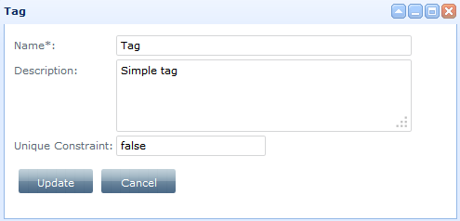
Figure 42: Edit tag
Edit the description of the tag (the only editable field) and click the “Update” button to save the changes or the “Cancel” button to cancel the procedure.

Delete Tag
Click on the delete icon () next to the tag you want to delete, in the table of tags. Selected tag will be deleted (if is not assigned to any object) and removed from the table of tags.

Relationships

Page Overview
The administrator may access the Relationships page by clicking on the “Relationships” tab from the main menu. The administrator can see all the available relationships, create a new or delete an existing relationship.
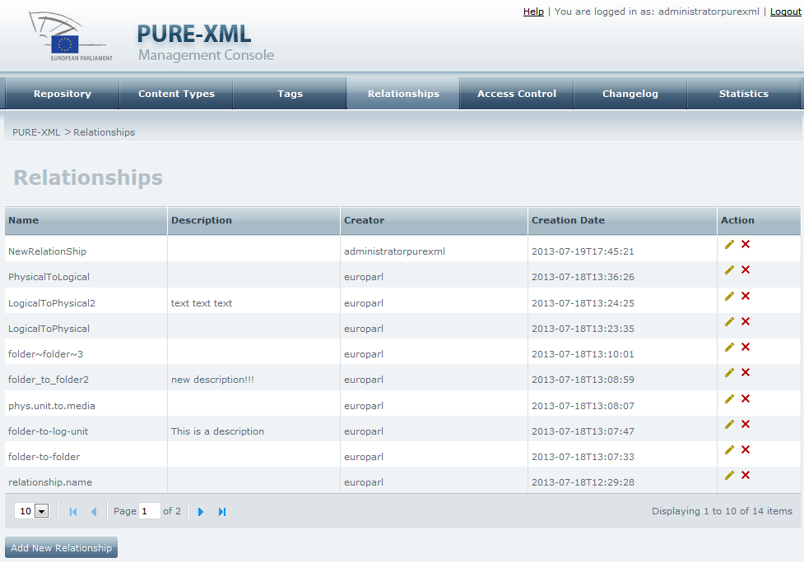
Figure 28: Relationships page

Actions

Add new Relationship
Click on the “Add New Relationship” button. The system will open a popup for adding a new relationship.
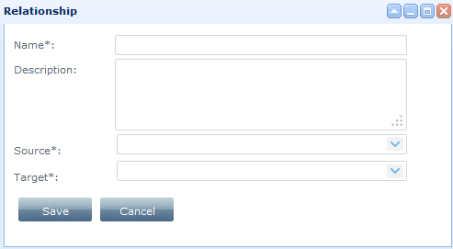
Figure 29: Add New Relationship
Fill in the name (mandatory, only “~”, “-”, “_”, “.” special characters allowed in the name), write a description (optional), select Source(s) and Target(s) of the relationship (mandatory) and click on the “Save” button. A new relationship will be created and displayed in the table of tags. Click on the “Cancel” button to cancel the procedure.
Note: You cannot relate an object to itself.

Edit Relationship
Click on the edit icon () next to the relationship you want to edit, in the table of relationships. A pop up window will appear. You can edit the description of the relationship as well as its Source and/or its Target. Removal of an existing Source or a Target can be completed only if the relationship is not yet assigned to any object; otherwise you can only add more sources or/and targets but not delete the existing ones.

Delete Relationship
Click on the delete icon () next to the relationship you want to delete, in the table of relationships. The System will ask for your confirmation and will either delete the relationship (if it is not assigned to any object), or cancel the procedure.

Access Control
The administrator may access the Access Control page by clicking on the “Access Control” tab from the main menu. The administrator can see the table containing all the available groups of users, create a new or delete an existing group of users.
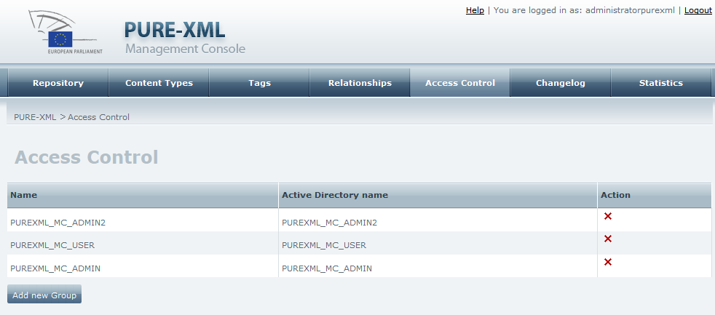
Figure 43: Access Control page

Add Group
Click on the “Add new Group” button. The system will open a popup for adding a new group of users.

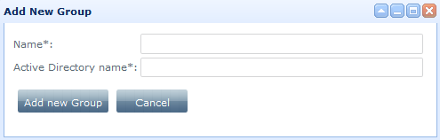
Figure 44: Add new user group
Fill in a name for the group (only “~”, “-”, “_”, “.” special characters allowed in the name) as well as the active directory name. Click on the “Add new Group” to complete the procedure or “Cancel” button to cancel it.

Delete Group
Click on the delete icon () next to the group you want to delete, in the table of groups. The System will ask for your confirmation and will either delete the group (if it is not used), or cancel the procedure.

Changelog

Page Overview
The Administrator may access the Changelog page by clicking on the “Changelog” tab from the main menu. The administrator can review the repository changelog and delete changelog entries.
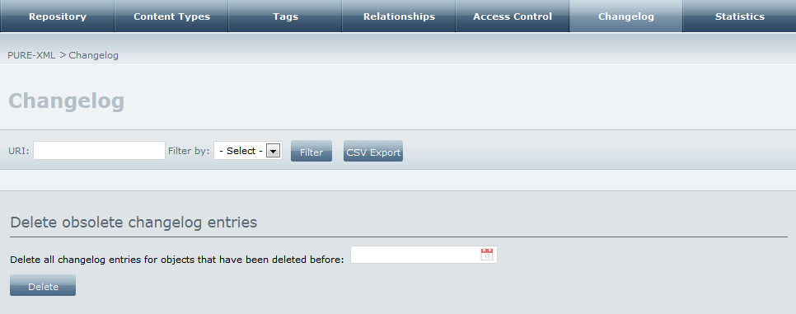
Figure 30: Changelog page
Changelog results can be filtered by Action, User, Date, object UBI, object ID or object URI.

Actions

Filter by URI
Fill in the URI of the object you want to find the changelog entries. Click on the “Filter” button.
Figure 45: Filter by URI
The system will fetch all changelog entries related to the specific object and its children objects. URI field can be used in combination with the other options from the “Filter by” drop down list.
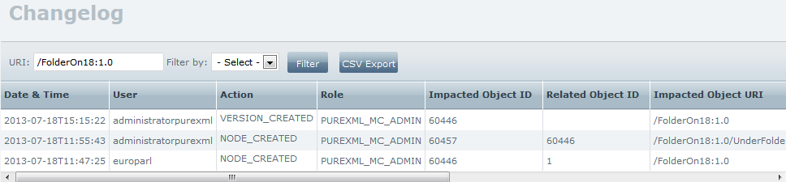
Figure 46: Changelog table

Filter by Action
Select “Action” option from the “Filter by” list, to filter the change log by type of action. Fill in an object’s URI to perform the filtering to the actions referring to this specific object and its children.
Figure 31: Filter by action
Select an action type for filtering and click on the “Filter” button. The system will display the changelog table that corresponds to the filtering options.
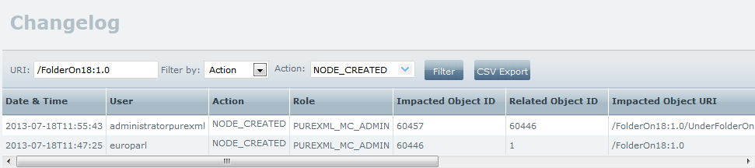
Figure 32: Changelog table
Leave the “URI” field empty to expand the filtering in all objects under the root folder (“/”).

Filter by user
Select “User” option from the “Filter by” list and fill in a specific Username to filter the change log by username. Fill in an object’s URI to perform the filtering to the actions done from the specific user, referring to this specific object and its children.
Figure 33: Filter by user
Click on the “Filter” button. The system will display the changelog table that corresponds to the filtering options.
Leave the “URI” field empty to expand the filtering in all objects under the root folder (“/”).
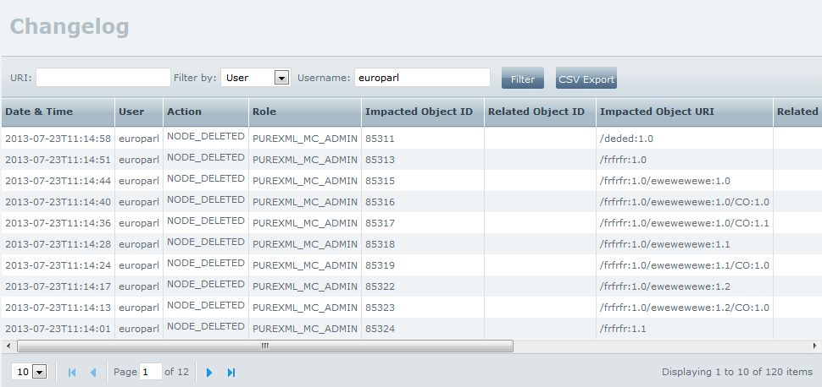
Figure 47: Changelog table

Filter by Date
Select “Date” option from the “Filter by” list, to filter the change log by date. Fill in an object’s URI to perform the filtering to the actions referring to this specific object and its children.
Figure 48: Filter by date
Select date and time and click on the “Filter” button. The system will display the changelog table that corresponds to the filtering options.
Leave the “URI” field empty to expand the filtering in all objects under the root folder (“/”).
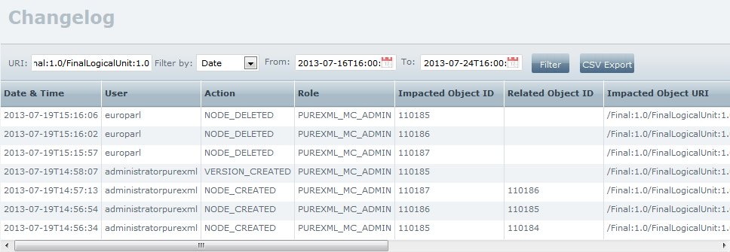
Figure 49: Changelog table

Filter by UBI
Select “UBI” option from the “Filter by” list, to filter the change log by object’s UBI.
Enter a UBI of a specific object in the “UBI” box and click on the “Filter” button.
Figure 50: Filter by UBI
The system will display the changelog table that corresponds to the filtering options.
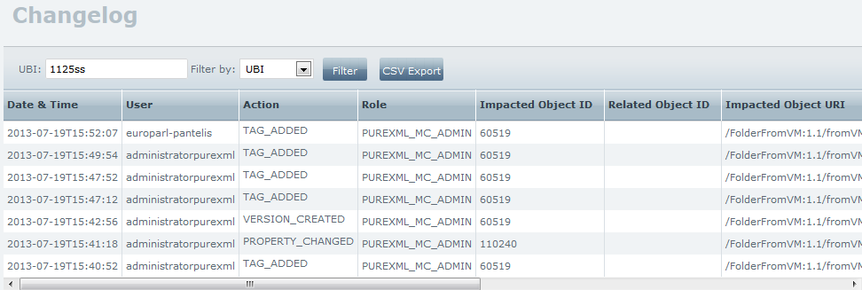
Figure 51: Changelog table

Filter by ID
Select “ID” option from the “Filter by” list, to filter the change log by object ID. Enter an ID of a specific object in the “ID” box and click on the “Filter” button.
Figure 52: Filter by ID
The system will display the changelog table that corresponds to the filtering options.
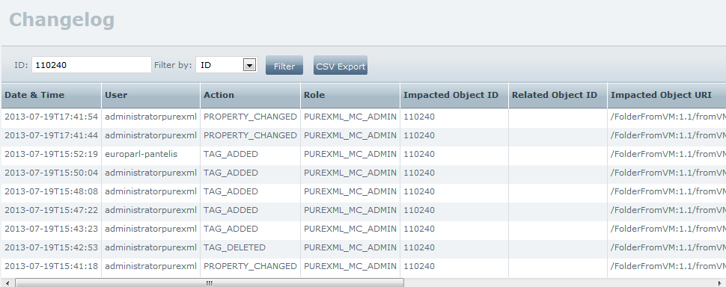
Figure 53: Changelog table

Export to CSV
Click on the “CSV Export” button to retrieve the changelog entries fetched by a previous query in .csv format.
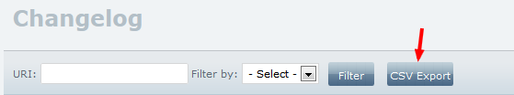
Figure 54: CSV Export
If no previous query in the changelog entries was done, the CSV export will contain the complete changelog.

Delete obsolete changelog entries
Select a date by clicking on the date picker next to the “Delete all changelog entries for objects that have been deleted before” label. Click the “Delete” button to delete all entries for objects that have been deleted before that date.
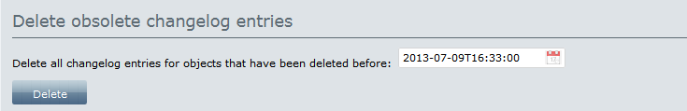
Figure 55: Delete changelog entries
The system will ask for your confirmation and will either delete the selected entries, or cancel the procedure.

Statistics
The Administrator may access the Statistics page by clicking on the “Statistics” tab from the main menu. The administrator can review the statistics related to the number of objects per object type, the number of objects per content type, and others (i.e. the number of tags per objects).
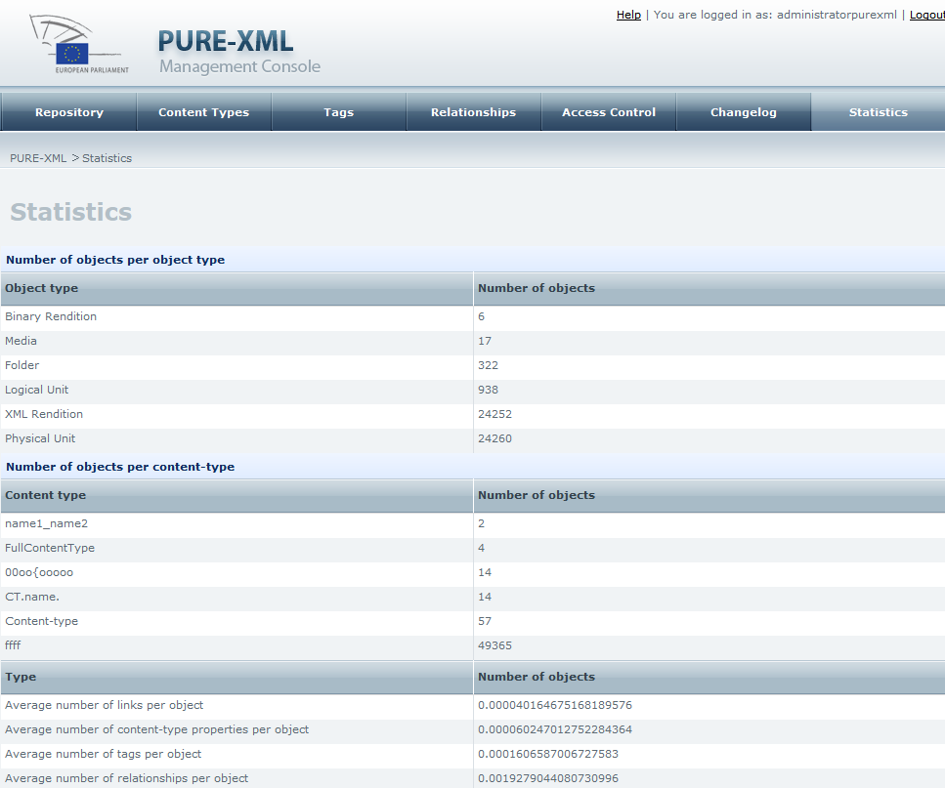
Figure 56: Statistics page

Folders

Page Overview
The administrator may access the Folder page by clicking on the “Edit” button (if the Folder object is selected in the navigation panel) or the edit icon () from the Repository Navigation page (if the Folder object is displayed in the contents view panel). The “Properties” tab is selected by default. (For available actions see “Properties view” section).

Actions

Composition - View Logical Units
Click on the “Composition” tab. Under the subtab “Logical layer”, a table with all the contained logical units inside the folder appear.

Composition - Edit /Link /Move /Delete /Lock Logical Units
Click on the specific icon from the table of logical units to execute the corresponding action (same as for edit/link/unlink/move/delete action available in the Repository Navigation page).

Composition - Add Logical Unit
Click on the “Add Logical Unit” button to add a new logical unit under the specific folder.

Versions -View version history
Click on the “Versions” tab to see the version history of the folder.

Versions -View version sequence
Click on the Version sequence icon next to a repository object () to see the version sequence of this object.

Versions -Edit a version of the folder
Click on the edit icon () to edit a specific version of the folder.

Versions -Check out a folder
Click on the () button to check out a specific version of the folder, so as to create a new version. A “Check-out” pop-up window appears.
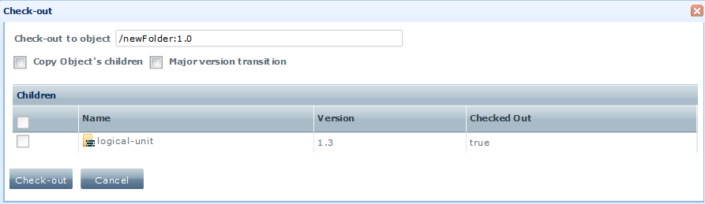
Figure 57: Check out a folder
Select “Copy Object’s children” option if you want to copy all/some of the folder’s child objects to the new version. Select “Major version transition” if you want to make a major version transition. Leave this selection unchecked if you want to make a minor version transition. Click on the “Check-out” button.

Versions -Check in
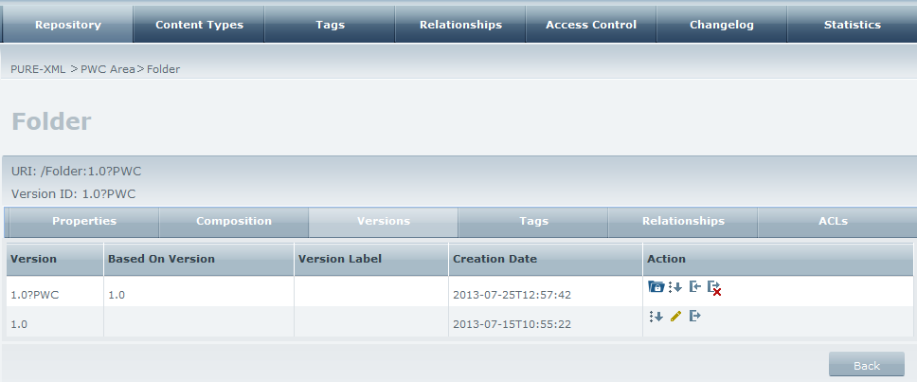
Figure 58: Check in
Click on the check-in icon () of a PWC to complete the check out procedure.

Versions -Cancel check out
Click on the cancel check-in icon () icon to cancel the check out procedure.

Versions – Open PWC area
Click on the pwc area icon () to open the PWC area (see paragraph 3.15).

Relationships -View Relationships
Click on the “Relationships” tab to view all relationships that ‘use’ this folder as a source or a target. Click on the links on “Target” and “Source” columns to be redirected to the corresponding objects.
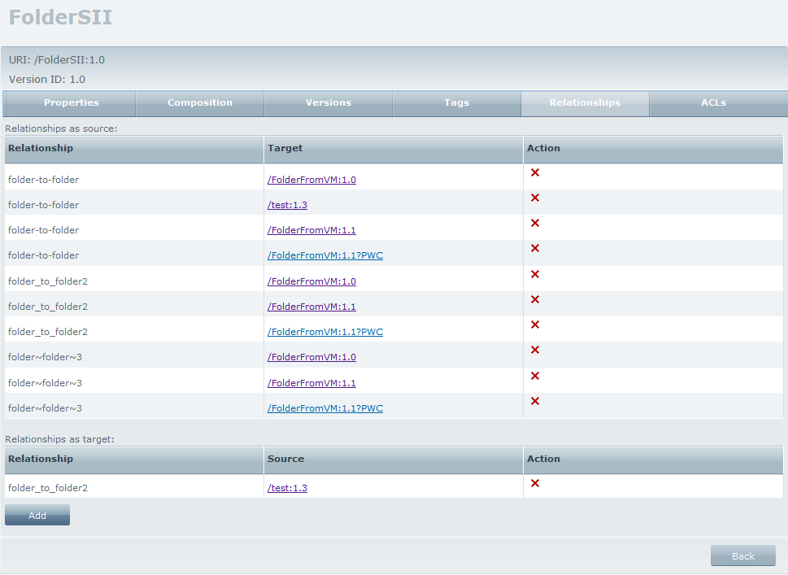
Figure 59: View relationships

Relationships -Add Relationships
Click on the “Add” button to add a new relationship, which will have this folder as a source.
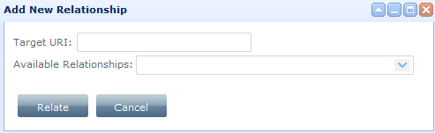
Figure 60: Add new relationship to a folder
Fill in the target URI and select one of the available relationships. Click on the “Relate” button to complete the action or the “Cancel” button to cancel it.

Relationships -Delete Relationships
Click on the delete icon () next to the relationship you want to delete, in order to delete it. The process is completed if the specific relationship is not used.

ACLs - Add new permission (ACE) to a group
Click on the “ACLs” tab. To add a new permission (ACE) for the specific object to a group, select the group from the “Name” drop-down list and the permission you want to assign to this group from the “Permission” drop-down list.
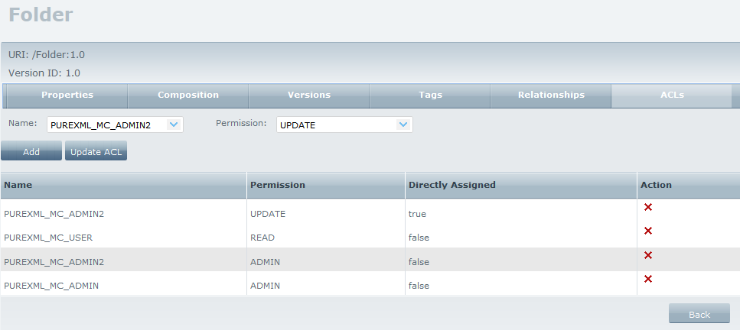
Figure 61: ACLs tab
Click on the “Add” button to add the new permission; the new permission is visible in the permissions table. The permission assignment acts recursively; the permissions apply to the object’s children, too.
Note: Directly assigned ACEs overwrite the indirectly assigned ACEs for the same object. Overwritten ACEs are grey highlighted.

ACLs - Delete existing permission from a group
Click on the delete icon () next to the permission you want to delete, in order to delete it.

ACLs – Define the ACL for an object
Click on the “Update ACL” button to define the ACL for the specific object. A pop up window appears.
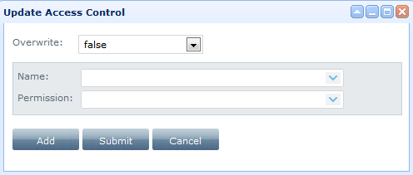
Figure 62: “Update Access Control” window
Select the User group from the “Name” drop-down list. Select the permission level to assign to this group from the “Permission” drop-down list. Click on the “Add” button to expand the pop up window and define more permissions for any group.
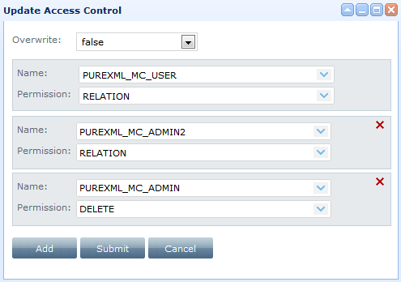
Figure 63: Expand the “Update Access Control” window
Click on the button to delete an ACL entry.
Define if the ACL you create will overwrite the existing ACL of the object or not by selecting a value in “Overwrite” drop-down list (true/false correspondingly, false is selected by default). Once having finished, click on the “Submit” button to apply your changes.
Click on the “Cancel” button to cancel the process.

Logical Units

Page Overview
The administrator may access the Logical Unit page by clicking on the “Edit” button (if the Logical Unit object is selected in the navigation panel) or the edit icon () from the Repository Navigation page (if the Logical Unit object is displayed in the contents view panel) . The “Properties” tab is selected by default. (For available actions see “Properties view” section).

Actions

Composition - Logical layer - View Logical Unit child objects
Click on the “Composition” tab and on the “Logical layer” subtab. The system will display a table with all Logical Units that are child objects of the selected logical unit.
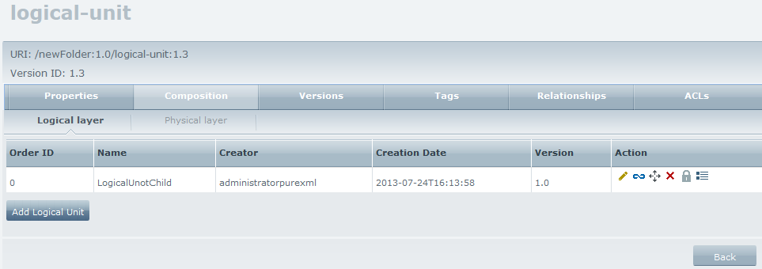
Figure 64: Logical Composition table

Composition - Logical layer - Edit/Link/Unlink/Move/Delete Logical Unit
Click on “Logical layer” subtab. Click on the specific icon from the table of logical units to execute the desired action (same actions as for edit/link/unlink/move/delete actions available in the Repository Navigation page - see section 3.1.2).

Composition - Logical layer - Add Logical Unit
Click on the “Logical layer” tab and then click on the “Add Logical Unit” button. The system will open a popup for adding a new logical unit under the selected logical unit.
Fill in the form and click on the “Add” button. A new Logical Unit will be created and displayed in the table of logical units.

Composition - Physical Layer - View Logical Unit child objects
Click on “Physical Layer” subtab. The system will display the table with all Physical Units that are child objects of the selected Logical Unit.
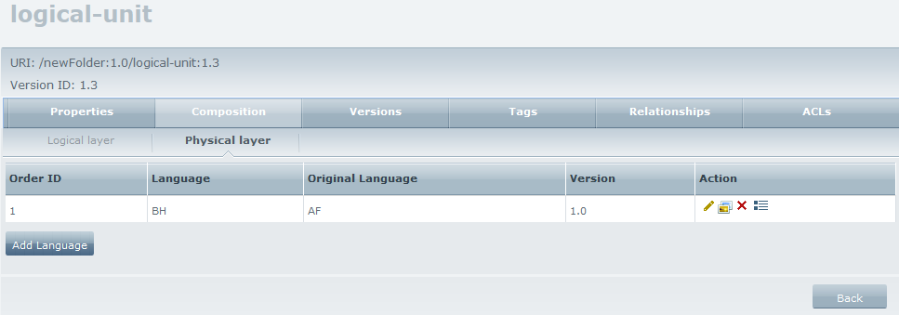
Figure 65: Table of Languages

Composition - Physical Layer - Add Language
Click on the “Physical Layer” subtab and then click on the “Add Language” button. The system will open a popup for adding a new language (Physical Unit).
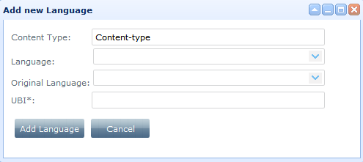
Figure 66: Add New Language
Fill in the form and click on the “Add Language” button. A new language will be created and displayed in the table of languages.

Composition - Physical Layer - Edit/Delete language
Click on the “Physical Layer” tab. Click on the specific icon from the table of languages to execute the corresponding action (same as for edit/delete actions available in the Repository Navigation page).

Composition - Physical Layer - View language
Click on the “Physical Layer” subtab. Click on the view icon () next to the language you want to view. The system will open the content page of the specific language, consisting of two panels: “Renditions” and “Media”. (See paragraph 3.11.2.1 below)

Composition - Physical Layer - View language versions
Click on the version button () to open the versions tab of the specific language.

Versions - View version sequence
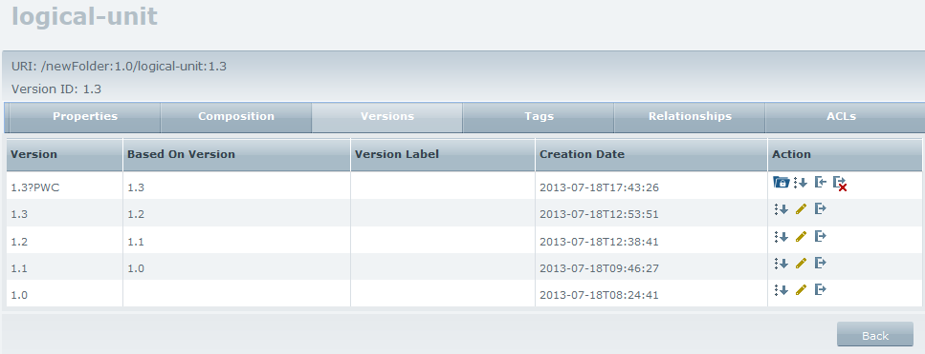
Figure 67: Versions tab for a logical unit
Click on the Version sequence icon () to see the version sequence of the object.
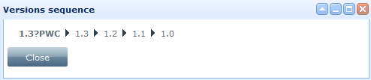
Figure 68: Versions sequence

Versions - Edit a version of the object
Click on the edit icon () to edit a specific version of the repository object.

Versions - Check out a logical unit
Click on the “Versions” tab. Click on the () button to check out a specific version of the repository object, so as to create a new version. A “Check-out” pop-up window appears.
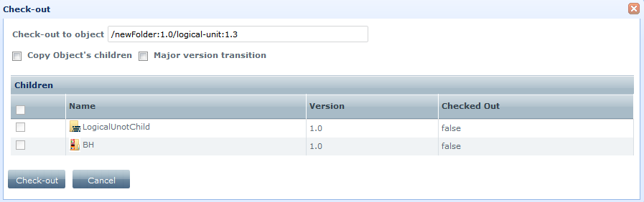
Figure 69: Check out a logical unit
Select “Copy Object’s children” option if you want to copy all/some of the folder’s child objects to the new version. Select “Major version transition” if you want to make a major version transition. Leave this selection unchecked if you want to make a minor version transition. Click on the “Check-out” button.

Versions - Check in
Click the check-in icon () of a PWC object to create a new version of the object in the repository using the PWC contents.

Versions - Cancel check out
Click on the () icon to cancel the check out procedure.

Versions – Open PWC area
Click on the pwc area icon () to open the PWC area (see paragraph 3.15).

Tags -View Tags
Click on the “Tags” subtab to view all Tags attached to the logical unit.

Tags -Add Tags
Select a tag from the “Add tag” list and click on the “Add” button to assign the selected Tag to the logical unit.

Tags -Delete Tags
Click on the delete icon () to delete an already assigned tag(s).

Relationships -View Relationships
Click on the “Relationships” tab to view all relationships that ‘use’ this logical unit as a source or a target. Click on the links on “Target” and “Source” columns to be redirected to the corresponding objects.

Relationships -Add Relationships
Click on the “Add” button to add a new relationship, which will have this logical unit as a source.
Figure 70: Add new relationship to a logical unit
Fill in the target URI and select one of the available relationships. Click on the “Relate” button to complete the action or the “Cancel” button to cancel it.

Relationships -Delete Relationships
Click on the delete icon () next to the relationship you want to delete, in order to delete it.

ACLs - Add new permission (ACE) to a group
Click on the “ACLs” tab. To add a new permission (ACE) for the specific object to a group, select the group from the “Name” drop-down list and the permission you want to assign to this group from the “Permission” drop-down list.
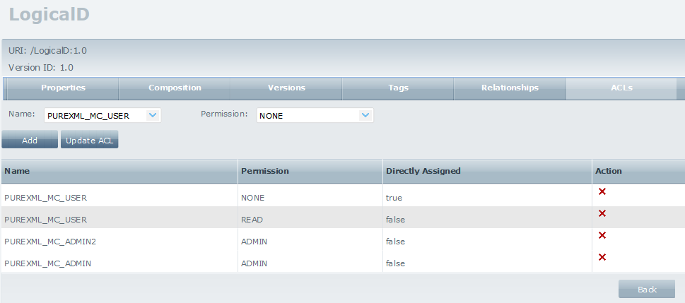
Figure 71: ACLs tab
Click on the “Add” button to add the new permission; the new permission is visible in the permissions table. The permission assignment acts recursively; the permissions apply to the object’s children, too.
Note: Directly assigned ACEs overwrite the indirectly assigned ACEs for the same object. Overwritten ACEs are grey highlighted.

ACLs - Delete existing permission from a group
Click on the delete icon () next to the permission you want to delete, in order to delete it.

ACLs – Define the ACL for an object
Click on the “Update ACL” button to define the ACL for the specific object. A pop up window appears.
Figure 72: “Update Access Control” window
Select the User group from the “Name” drop-down list. Select the permission level to assign to this group from the “Permission” drop-down list. Click on the “Add” button to expand the pop up window and define more permissions for any group.
Figure 73: Expand the “Update Access Control” window
Click on the button to delete an ACL entry.
Define if the ACL you create will overwrite the existing ACL of the object or not by selecting a value in “Overwrite” drop-down list (true/false correspondingly, false is selected by default). Once having finished, click on the “Submit” button to apply your changes.
Click on the “Cancel” button to cancel the process.

Physical Units

Page Overview
The administrator may access the Physical Unit page by clicking on the “Edit” button, if the Physical Unit object is selected in the navigation panel, or the edit icon (), if the Physical Unit object is displayed in the contents view panel, from the Repository Navigation page . The “Properties” tab is selected by default. (For available actions see “Properties view” section).

Actions

Composition – Renditions - View Renditions
Click on the “Composition” tab. Under the subtab “Renditions”, all the contained renditions inside the physical unit appear.

Composition – Renditions - Edit /Delete Renditions
Click on the specific icon from the table of logical units to execute desired action (same as for edit/delete action available in the Repository Navigation page).

Composition – Renditions - Add new rendition
Click on the “Add Rendition” button to add a new rendition (XML or binary) to the specific physical unit. The system will open a popup for adding a new Rendition.
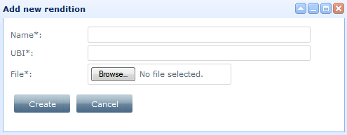
Figure 74: Add new Rendition
Fill in the form and click on the “Create” button (all fields are mandatory). The system will save the Rendition.

Composition – Media - View media content
Click on the “Composition” tab. Under the subtab “Media”, all the contained media inside the physical unit appear.

Composition – Media - Add Media
Click on the “Add Media” button. The system will open a popup for you to add the new Media object (see paragraph 3.10.2.5 ).

Composition – Media - Edit/Delete Media
Click on the specific icon from the table of media objects to execute the corresponding action (same as for edit/delete action available in the Repository Navigation page).

Composition – Media - View Media
Click on the content icon () from the table of media objects. The system will ask if you want to save or open the Media file. Select an action and click “OK”. The media file will be opened/saved.

Versions -View version history
Click on the “Versions” tab to see the version history of the physical unit.

Versions -View version sequence
Click on the Version sequence icon () to see the version sequence of the object.

Versions -Edit a version of the object
Click on the edit icon () to edit a specific version of the repository object.

Versions -Check out a physical unit
Click on the () button to check out a specific version of the repository object, so as to create a new version. A “Check-out” pop-up window appears.
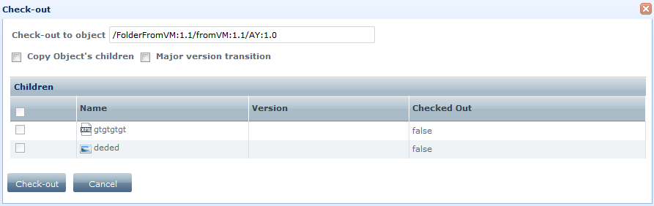
Figure 75: Check out a physical unit
Select “Copy Object’s children” option if you want to copy all/some of the folder’s child objects to the new version. Select “Major version transition” if you want to make a major version transition. Leave this selection unchecked if you want to make a minor version transition. Click on the “Check-out” button.

Versions -Check in
Click on the check-in icon () of a PWC object to complete the check out procedure.

Versions -Cancel check out
Click on the () icon to cancel the check out procedure.

Versions – Open PWC area
Click on the pwc area icon () to open the PWC area (see paragraph 3.15).

Tags -View Tags
Click on the “Tags” subtab to view all Tags attached to the logical unit.

Tags -Add Tags
Select a tag from the “Add tag” list and click on the “Add” button to assign the selected Tag to the physical unit.

Tags -Delete Tags
Click on the delete icon () to delete an already assigned tag(s).

Relationships - View Relationships
Click on the “Relationships” tab to view all relationships that ‘use’ this folder as a source or a target. Click on the links on “Target” and “Source” columns to be redirected to the corresponding objects.

Relationships - Add Relationships
Click on the “Add” button to add a new relationship, which will have this folder as a source.
Figure 76: Add new relationship to a physical unit

Relationships - Delete Relationships
Click on the delete icon () next to the relationship you want to delete, in order to delete it.

ACLs - Add new permission (ACE) to a group
Click on the “ACLs” tab. To add a new permission (ACE) for the specific object to a group, select the group from the “Name” drop-down list and the permission you want to assign to this group from the “Permission” drop-down list.
Click on the “Add” button to add the new permission; the new permission is visible in the permissions table. The permission assignment acts recursively; the permissions apply to the object’s children, too.
Note: Directly assigned ACEs overwrite the indirectly assigned ACEs for the same object. Overwritten ACEs are grey highlighted.

ACLs - Delete existing permission from a group
Click on the delete icon () next to the permission you want to delete, in order to delete it.

ACLs – Define the ACL for an object
Click on the “Update ACL” button to define the ACL for the specific object. A pop up window appears.
Figure 77: “Update Access Control” window
Select the User group from the “Name” drop-down list. Select the permission level to assign to this group from the “Permission” drop-down list. Click on the “Add” button to expand the pop up window and define more permissions for any group.
Figure 78: Expand the “Update Access Control” window
Click on the button to delete an ACL entry.
Define if the ACL you create will overwrite the existing ACL of the object or not by selecting a value in “Overwrite” drop-down list (true/false correspondingly, false is selected by default). Once having finished, click on the “Submit” button to apply your changes.
Click on the “Cancel” button to cancel the process.

XML Renditions

Page Overview
The administrator may access the XML Rendition page by clicking on the edit icon () from the Repository Navigation page.
The “Properties” tab is selected by default. (For available actions see “Properties view” section).
On the top of the page appears the URI that links to the specific XML rendition. No versioning is supported here.

Actions

XML Content – XML - View/Update XML
Modify manually the XML Rendition file and click on the “Update XML” button. The system will update the XML Rendition file.

XML Content – XML - Update Xpath
Fill in the “Xpath” and “Value” fields. Click on the “Update Xpath” button. The system will update the selected Xpath with the provided value. Correct XPath queries should be used.

XML Content – HTML - View HTML presentation of XML Rendition file
Click on the “HTML” tab. The system will display HTML presentation of the selected XML Rendition file, using a predefined stylesheet for the target content type assigned to XML Rendition file.
HTML presentation of XML is made based on stylesheet and css file.
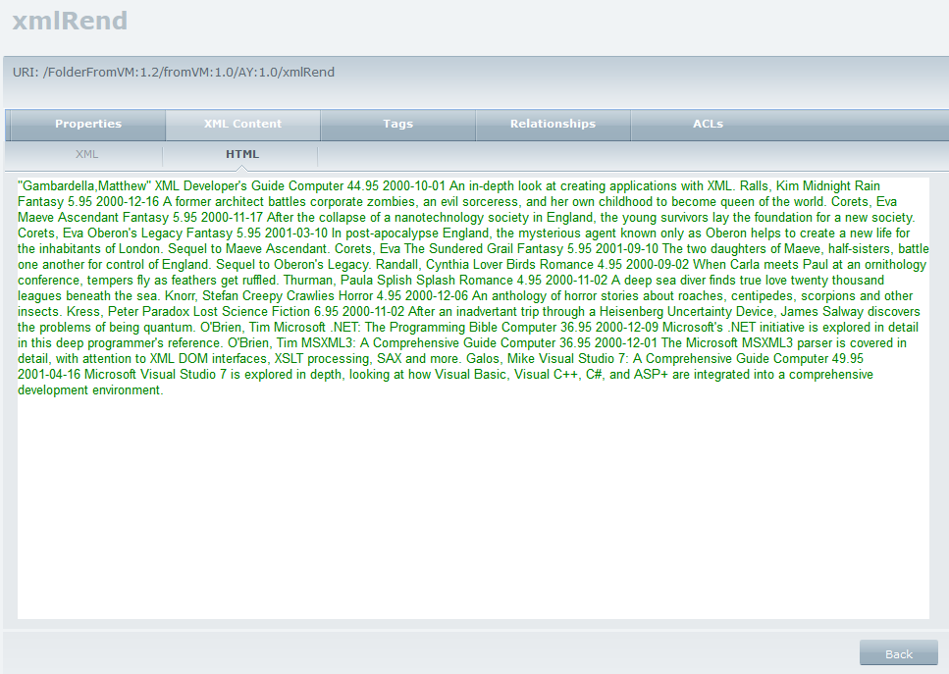
Figure 22: HTML presentation of XML Rendition file

Relationships -View Relationships
Click on the “Relationships” tab to view all relationships that ‘use’ this xml rendition as a source or a target.

Relationships -Add Relationships
Click on the “Add” button to add a new relationship, which will have this xml rendition as a source.
Figure 79: Add new relationship to an XML Rendition

Relationships -Delete Relationships
Click on the delete icon () next to the relationship you want to delete, to delete it.

ACLs - Add new permission (ACE) to a group
Click on the “ACLs” tab. To add a new permission (ACE) for the specific object to a group, select the group from the “Name” drop-down list and the permission you want to assign to this group from the “Permission” drop-down list.
Click on the “Add” button to add the new permission; the new permission is visible in the permissions table. The permission assignment acts recursively; the permissions apply to the object’s children, too.
Note: Directly assigned ACEs overwrite the indirectly assigned ACEs for the same object. Overwritten ACEs are grey highlighted.

ACLs - Delete existing permission from a group
Click on the delete icon () next to the permission you want to delete, in order to delete it.

ACLs – Define the ACL for an object
Click on the “Update ACL” button to define the ACL for the specific object. A pop up window appears.
Figure 80: “Update Access Control” window
Select the User group from the “Name” drop-down list. Select the permission level to assign to this group from the “Permission” drop-down list. Click on the “Add” button to expand the pop up window and define more permissions for any group.
Figure 81: Expand the “Update Access Control” window
Click on the button to delete an ACL entry.
Define if the ACL you create will overwrite the existing ACL of the object or not by selecting a value in “Overwrite” drop-down list (true/false correspondingly, false is selected by default). Once having finished, click on the “Submit” button to apply your changes.
Click on the “Cancel” button to cancel the process.

Binary Renditions

Page Overview
The administrator may access the Binary Rendition page by clicking on the edit icon () from the Repository Navigation page. The “Properties” tab is selected by default. (For available actions see “Properties view” section). On the top of the page appears the URI that links to the specific Binary rendition. No versioning is supported here.

Actions

Rendition Content -View Rendition
Click on the “Rendition content” tab and then on the “View Rendition” button. The system will ask if you want to save or open the Binary file. Select an action and click “OK”. The rendition file will be opened/saved.

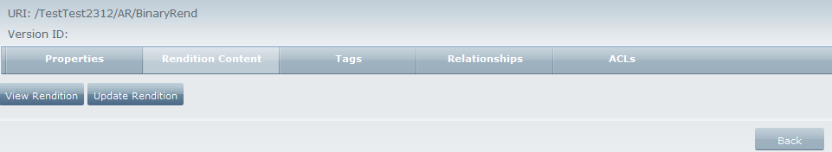
Figure 82: Rendition content

Rendition Content -Update Binary Rendition
Click on the “Rendition content” tab and then on the “Update Rendition” button. A pop up window will appear, to select a new binary rendition to replace the previous one.
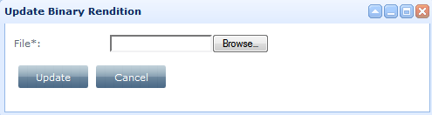
Figure 83: Update Binary Renditions
Click on the “Update” button to update the Binary rendition.

Relationships -View Relationships
Click on the “Relationships” tab to view all relationships that ‘use’ this xml rendition as a source or a target.

Relationships -Add Relationships
Click on the “Add” button to add a new relationship, which will have this xml rendition as a source.
Figure 84: Add new relationship to an XML Rendition

Relationships -Delete Relationships
Click on the delete icon () next to the relationship you want to delete, to delete it.

ACLs - Add new permission (ACE) to a group
Click on the “ACLs” tab. To add a new permission (ACE) for the specific object to a group, select the group from the “Name” drop-down list and the permission you want to assign to this group from the “Permission” drop-down list.
Click on the “Add” button to add the new permission; the new permission is visible in the permissions table. The permission assignment acts recursively; the permissions apply to the object’s children, too.
Note: Directly assigned ACEs overwrite the indirectly assigned ACEs for the same object. Overwritten ACEs are grey highlighted.

ACLs - Delete existing permission from a group
Click on the delete icon () next to the permission you want to delete, in order to delete it.

ACLs – Define the ACL for an object
Click on the “Update ACL” button to define the ACL for the specific object. A pop up window appears.
Figure 85: “Update Access Control” window
Select the User group from the “Name” drop-down list. Select the permission level to assign to this group from the “Permission” drop-down list. Click on the “Add” button to expand the pop up window and define more permissions for any group.
Figure 86: Expand the “Update Access Control” window
Click on the button to delete an ACL entry.
Define if the ACL you create will overwrite the existing ACL of the object or not by selecting a value in “Overwrite” drop-down list (true/false correspondingly, false is selected by default). Once having finished, click on the “Submit” button to apply your changes.
Click on the “Cancel” button to cancel the process.

Media

Page Overview
The administrator may access Media page by clicking on the edit icon () from the Repository Navigation. The “Properties” tab is selected by default. (For available actions see “Properties view” section). On the top of the page appears the URI that links to the specific Media object. No versioning is supported here.

Actions

Media Content - View Media
Click on the “Media Content” tab and then on “View Media” button. The system will offer you to save or open the Media file. Select desired action and click “OK”. The selected media file will be opened/saved.

Media Content - Update media
Click on the “Media content” tab and then on the “Update Media” button. A pop up window will appear, to select a new media file to replace the previous one.
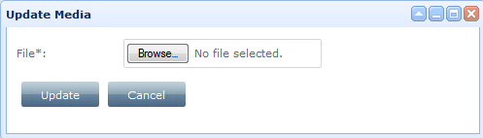
Figure 87: Update media
Click on the “Update” button to update the media file.

Relationships - View Relationships
Click on the “Relationships” tab to view all relationships that ‘use’ this media as a source or a target.

Relationships -Add Relationships
Click on the “Add” button to add a new relationship, which will have this media file as a source.
Figure 88: Add new relationship to an XML Rendition

Relationships -Delete Relationships
Click on the delete icon () next to the relationship you want to delete, to delete it.

ACLs - Add new permission (ACE) to a group
Click on the “ACLs” tab. To add a new permission (ACE) for the specific object to a group, select the group from the “Name” drop-down list and the permission you want to assign to this group from the “Permission” drop-down list.
Click on the “Add” button to add the new permission; the new permission is visible in the permissions table. The permission assignment acts recursively; the permissions apply to the object’s children, too.
Note: Directly assigned ACEs overwrite the indirectly assigned ACEs for the same object. Overwritten ACEs are grey highlighted.

ACLs - Delete existing permission from a group
Click on the delete icon () next to the permission you want to delete, in order to delete it.

ACLs – Define the ACL for an object
Click on the “Update ACL” button to define the ACL for the specific object. A pop up window appears.
Figure 89: “Update Access Control” window
Select the User group from the “Name” drop-down list. Select the permission level to assign to this group from the “Permission” drop-down list. Click on the “Add” button to expand the pop up window and define more permissions for any group.
Figure 90: Expand the “Update Access Control” window
Click on the button to delete an ACL entry.
Define if the ACL you create will overwrite the existing ACL of the object or not by selecting a value in “Overwrite” drop-down list (true/false correspondingly, false is selected by default). Once having finished, click on the “Submit” button to apply your changes.
Click on the “Cancel” button to cancel the process.

PWC area

Page overview
PWC is the area the user is redirected to, when editing a PWC object. After you have checked out a repository object, click on the pwc area icon () to open the PWC area. You can do this either from the Repository page, either from the “Versions” tab of a specific object.
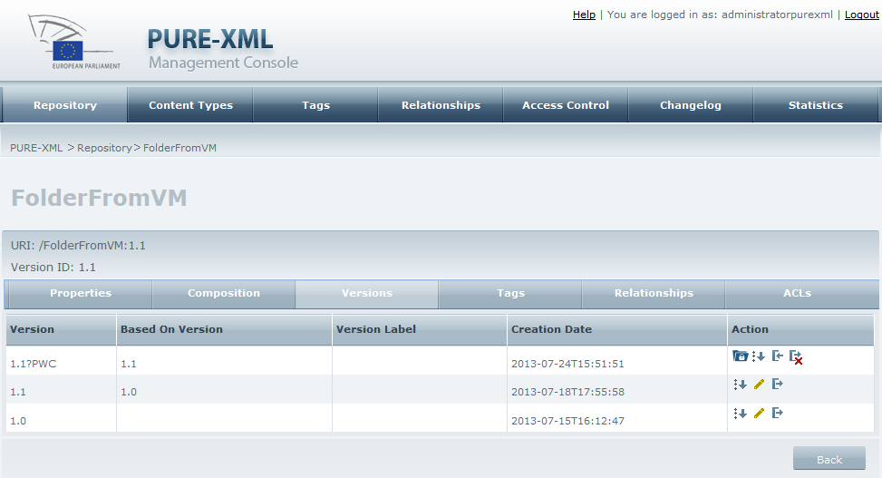
Figure 91: Open the PWC area from the “Versions” tab
PWC area is the main repository navigation page, having only PWC object in the navigation panel. Three more buttons are added here: “Exit PWC area”, “Check-in” and “Cancel check-out”.
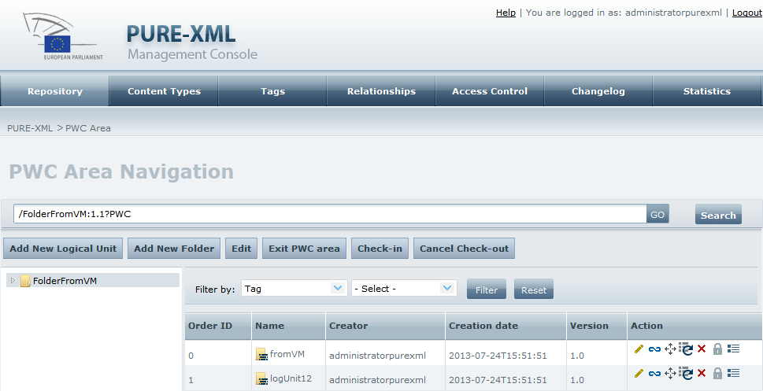
Figure 92: PWC area
PWC is the private working copy for the user that checked the initial object out and cannot be accessed by any other user. You can make any action on the repository object (and on any of its children, if you have selected them to be checked out), without your changes to be visible from other users.

Actions

Add new logical Unit
Same action as in the Repository Area Navigation.

Add new Folder
Same action as in the Repository Area Navigation.

Edit
Same action as in the Repository Area Navigation with one exception: editing the name of the object is not allowed.

Check in
Click on the “Check-in” button to complete the check out procedure.

Cancel check out
Click on the “Cancel Check-out” button to cancel the check out procedure.

Exit PWC area
Click on the “Exit PWC area” button to be redirected to the repository navigation main page. The check-out object is selected from the contents panel and its contents appear in the content view pane.

Using the Management Console as a User

Repository Navigation

Page Overview
The Repository Navigation page is the PURE-XML MC application homepage. When user logs into the system, the Repository tab is automatically loaded. No other tabs are loaded.
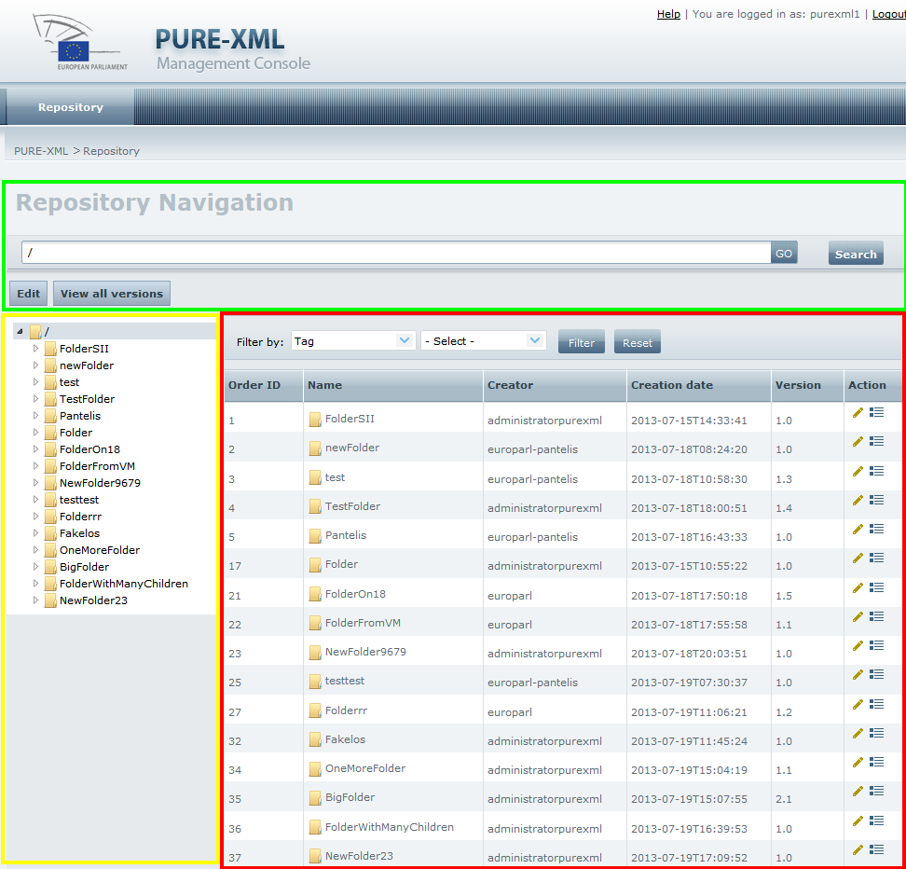
Figure 93: The main areas of the Repository Navigation page
The Repository Navigation page consists of three panels: action panel (green), navigation panel (yellow) and contents view panel (red).

Actions

Navigate through the repository objects
Click on a repository object in the navigation panel. If the selected object is not empty, its children (one level down) will be displayed in the contents view panel.
Click on the arrow in the left side of a repository object in the navigation panel to expand it.

View the contents of a repository object from the contents view panel
Double-click on a repository object in the contents view panel to view its children objects (if any).

Go to object using object URI
Fill in the full URI of a repository object in the text box in the action panel and click on the “GO” button. The full URI must include all the version identifiers of the versionable objects in the path. For example, /FOlDER:1.0/LogdoC:2.0/CE:1.0 URI corresponds to the 1.0 version of the “CE” physical unit, which is child of the 2.0 version of the “LogdoC” logical unit, which is child of the 1.0 version of the “FOlDER” folder.
Figure 94: Retrieve an object by providing the object URI
The system will select the object with the URI provided (if such object exists) in the navigation panel and display the selected object’s contents in the contents view panel.
In case user fills in an invalid URI or a URI that no longer exists (e.g. due to the object having been moved, renamed or deleted in the mean time), the system will inform him/her with the corresponding error messages.
In addition, if a user provides a URI of a rendition or a media object in the text box, he/she will get an error message, as media and renditions are not depicted in the navigation panel.

Search
Click on the ‘Search’ button, next to the ‘GO’ button to search for the object that corresponds to the full URI contained in the URI text box, as well as for its children (recursive search).
Figure 95: ‘Search’ button
The system opens the Search screen where the parent URI field is already completed.
You can edit the ‘Parent URI’ field and/or fill in any of the search fields; the use of the operator (next to the search criteria that is used) wherever it exists, is required in order the search criteria to be correctly performed. Select a sorting type under the “Order by” panel, to sort the search results. Click on the “Search” button to view the search results.

View repository object
Select a repository object from the navigation panel and click on the “Edit” button. The Read only view will be opened with tabs related to the selected object (Properties, Composition, Versions). The user can also click on the edit icon () from the contents view panel and the same action will be performed for the object from the contents view panel.

Versioning information of the repository object
Click on the versions icon () from the contents view panel to open the “Versions” tab of the repository object.

View all versions
Click on the “View all versions” button from the action panel to see all the versions of all repository objects in both navigation and contents view panels.

View latest version
Click on the “View latest version” button from the action panel to restore the Repository view to show only the latest versions of the repository objects.

Filter contents of folder and folder-derived objects
Click on a non-empty repository object from the navigation panel. From the action panel you can execute filtering by tag, content type property or system property.
Figure 96: Filter panel
Select filtering parameters choosing among Tag, System property or CT property and click on the “Filter button”. The system will execute filtering one level down form the selected object and refresh the content view pane, displaying only the items satisfying the selected filter.

Properties view

Page overview
The user may access Properties View page by clicking on the “Edit” button (for the object selected in the navigation panel) or the edit icon () from the Repository Navigation page (for the target object displayed in the contents view panel). The “Properties” tab will be selected automatically. The user can navigate through the tabs and view all the properties of a selected repository objects.
The Properties view page can have one, two or three tabs: System (for system properties, applicable to all repository objects), Content Type (for content type properties, applicable to all repository objects except for Folders) and XML metadata properties (for XML metadata properties applicable for XML rendition objects only).
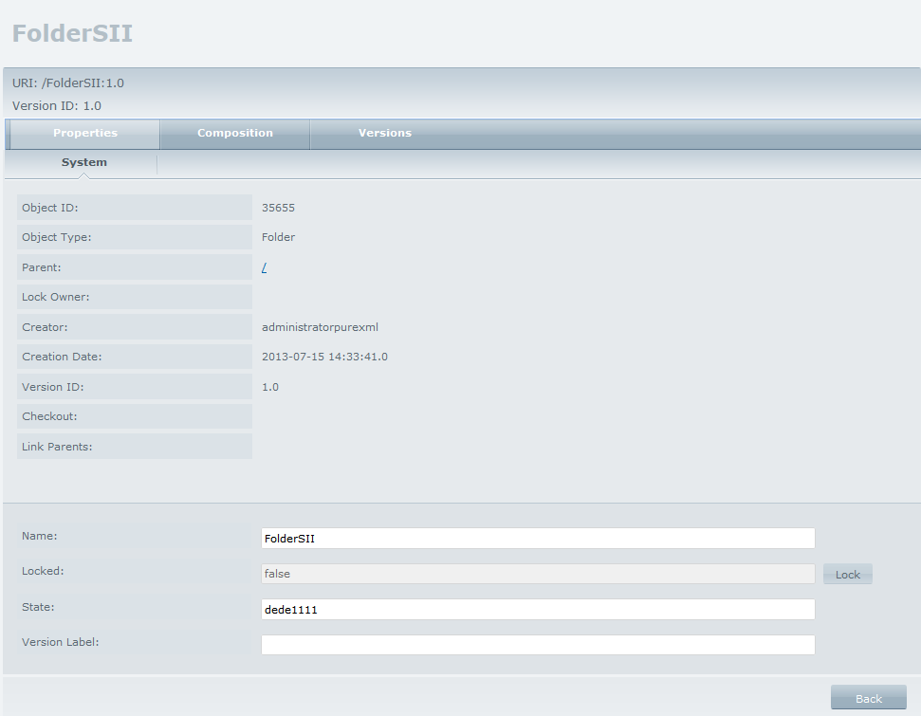
Figure 97: Folder System properties

Actions

Properties - View System Properties
Click on the “Properties” tab to have a view of all the repository object’s System properties.

Properties - Go to parent object
Click on the “Parent” link from the system properties tab. The system will redirect you to the Repository Navigation page. The parent object will be selected. If parent has child objects, it will be expanded and its child objects will be displayed in the contents view panel.

Content type properties - View Content type properties
Click on the “Properties” tab and on the “Content Type” subtab to have a view of all the object’s Content type properties.

XML Metadata Properties -View XML Metadata Properties
Click on the “Properties” tab and then on the “XML Metadata” subtab to have a view of all the XML rendition Metadata Properties.

Folders

Page Overview
The user may access the Folder page by clicking on the “Edit” button (if the Folder object is selected in the navigation panel) or the edit icon () from the Repository Navigation page (if the Folder object is displayed in the contents view panel). The “Properties” tab is selected by default.
On the top of the page appears the URI that links to the specific folder, as well as a label with the folder’s version ID.

Actions

Composition - View Logical Units
Click on the “Composition” tab. Under the subtab “Logical layer”, all the contained logical units inside the folder appear.

Composition - “Edit” Logical Units
Click on the edit icon () next to a logical unit from the table of logical units to navigate through logical unit properties and contents.

Composition - View logical units versioning
Click on the Versions icon () to see the version history of the folder.

Versions -View version history
Click on the “Versions” tab to see the version sequence of the object.

Versions - “Edit” a version of the object
Click on the edit icon () to edit a specific version of the repository object.

Logical Units

Page Overview
The user may access the Logical Unit page by clicking on the “Edit” button (if the Logical Unit object is selected in the navigation panel) or the edit icon () from the Repository Navigation page (if the Logical Unit object is displayed in the contents view panel).
The “Properties” tab is selected by default.
On the top of the page appears the URI that links to the specific logical unit, as well as a label with the logical unit’s version ID.

Actions

Composition - Logical layer - View Logical Unit child objects
Click on the “Logical Composition” tab and on the “Logical layer” subtab. The system will display the table with all Logical Units that are child objects of the selected one.

Composition - Physical layer - View Physical Unit child objects
Click on “Physical Layer” subtab. The system will display the table with all Physical Units that are child objects of the selected Logical Unit.
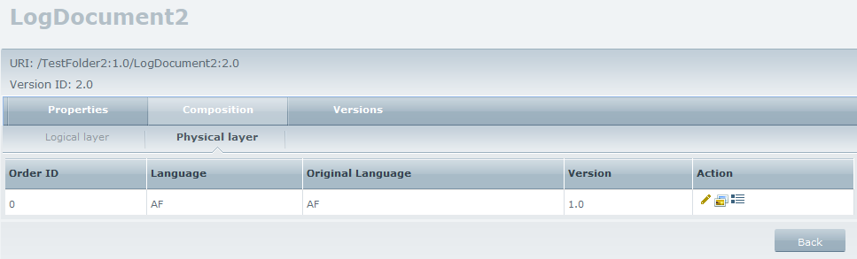
Figure 98: Physical Composition table

Composition - Physical layer - “Edit” language
Click on the edit icon () next to a physical unit from the table of physical units to navigate through physical units properties and contents.

Composition - Physical layer - View language Content
Click on the “Physical Layer” subtab. Click on the view content icon (). The system will open the content page of the specific language, consisting of two panels: “Renditions” and “Media”.

Composition - Physical layer - View language versions
Click on the version button () to open the versions tab of the specific language.

Physical Units

Page Overview
The user may access the Physical Unit page by clicking on the “Edit” button, if the Physical Unit object is selected in the navigation panel, or the edit icon (), if the Physical Unit object is displayed in the contents view panel, from the Repository Navigation page.
The “Properties” tab is selected by default.
On the top of the page appears the URI that links to the specific logical unit, as well as a label with the logical unit’s version ID.
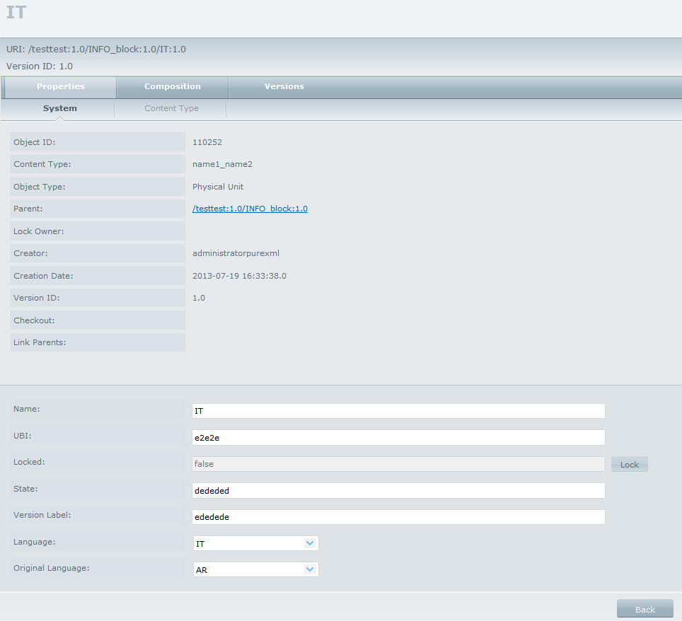
Figure 99: Physical Unit Properties page

Actions

Composition – Renditions -View Renditions
Click on the “Composition” tab. Under the subtab “Renditions”, all the contained renditions inside the physical unit appear.

Composition – Renditions –“Edit” Renditions
Click on the edit icon () next to a rendition from the table of renditions to navigate through renditions’ properties and contents.

Composition – Media –View media content
Click on the “Composition” tab. Under the subtab “Media”, all the contained media inside the physical unit appear.

Composition – Media –View Media
Click on the content icon () from the table of media objects. The system will ask if you want to save or open the Media file. Select an action and click “OK”. The media file will be opened/saved.

Composition – Media –“Edit” Media
Click on the edit icon () next to a media from the table of media objects to navigate through media’s properties and contents.

Versions -View version history
Click on the “Versions” tab to see the version history of the physical unit.

Versions - “Edit” a version of the object
Click on the edit icon () to edit a specific version of the repository object.

XML Renditions

Page Overview
The user may access the XML Rendition page by clicking on the edit icon () from the Repository Navigation page.
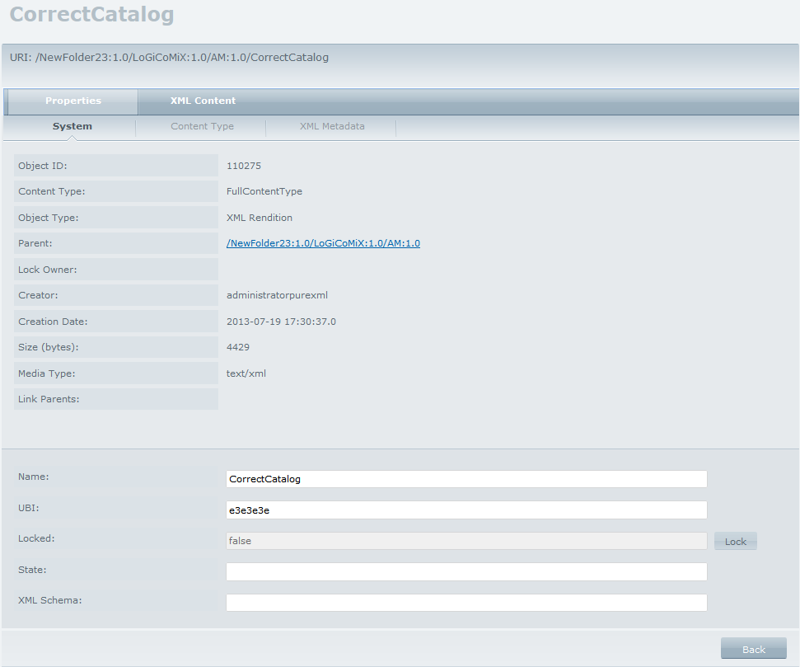
Figure 100: XML Rendition System properties page

Actions

XML Content – XML - View XML
Click on the “XML Content” tab and then to the “XML” subtab to view the XML Rendition.

XML Content – HTML - View HTML presentation of XML Rendition file
Click on the “HTML” tab. The system will display HTML presentation of the selected XML Rendition file, using a predefined stylesheet for the target content type assigned to XML Rendition file.
HTML presentation of XML is made based on stylesheet and css file.
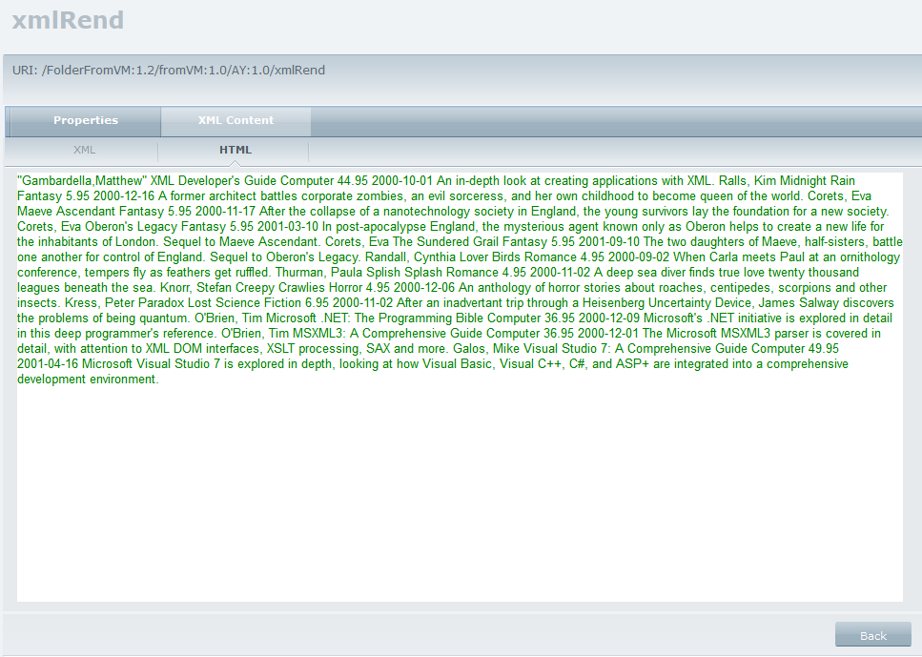
Figure 22: HTML presentation of XML Rendition file

Binary Renditions

Page Overview
The user may access the Binary Rendition page by clicking on the edit icon () from the Repository Navigation page.
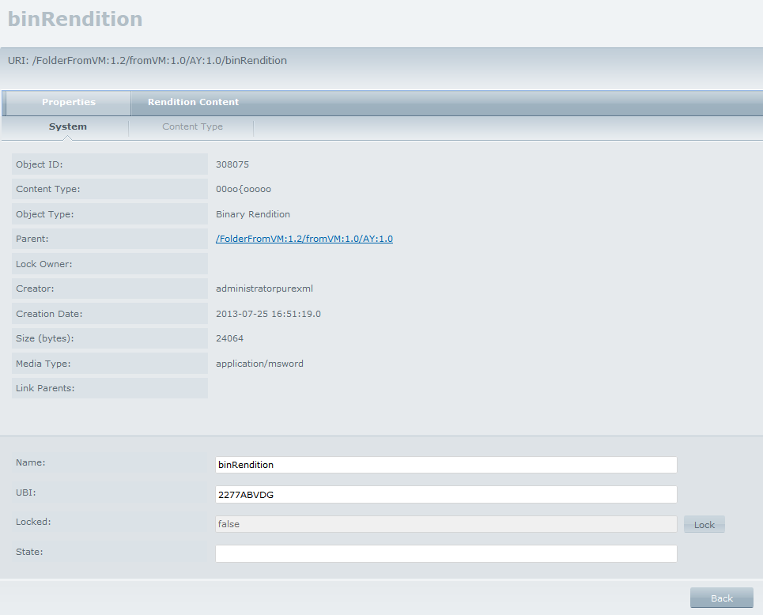
Figure 101: Binary Rendition System Properties view

Actions

Rendition Content - View Rendition
Click on the “Rendition content” tab and then on the “View Rendition” button. The system will ask if you want to save or open the Binary file. Select an action and click “OK”. The rendition file will be opened/saved.
Figure 102: Rendition content

Media

Page Overview
The user may access Media page by clicking on the edit icon () from the Repository Navigation.
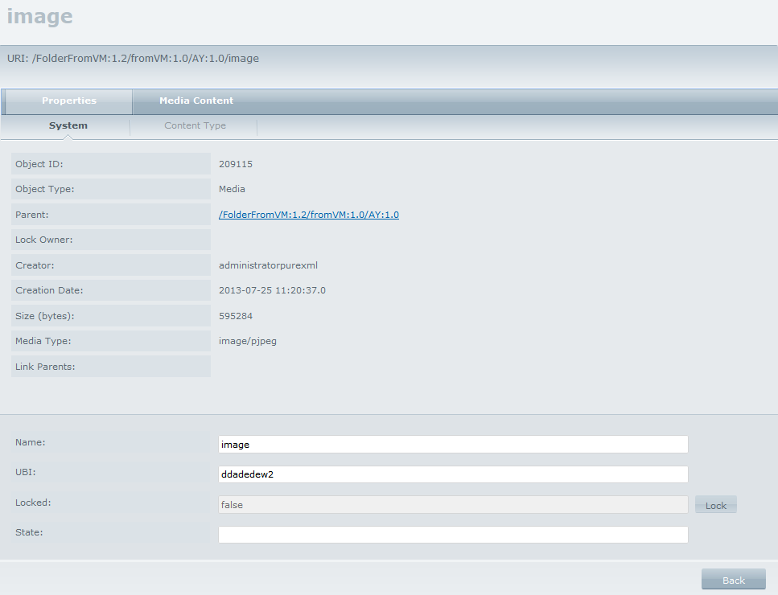
Figure 103: Media System Properties page

Actions

Media Content - View Media
Click on the “Media Content” tab and then on “View Media” button. The system will offer you to save or open the Media file. Select desired action and click “OK”. The selected media file will be opened/saved.
END OF DOCUMENT

